An analysis of multi-modal discourse on “coca-cola advertisement”

Willem Saragih
Faculty of Languages and Arts
State University of Medan

Abstract

Investigation into language seems to be never ending – not only in form and meaning but also in function and use in communication. In use, for example, recently, social semiotics as the development of semiotics has witnessed the move from the dominance of monomodality to multimodality. Newspapers and magazines, computers, and mass media in general have articulated multimodal texts (combinations of video, audio, written text, etc.) that aim to reinforce, render more complex, or produce different meanings. This means that the investigation is more than about language, but attends to the full range of communicational forms people use which covers image, gesture, gaze, posture and so on- and the relationships between them. This article presents a multimodal analysis on video advertisement entitled “https://www.google.com/?Funny, Commercial Coca-Cola, Producer, Director, Victor Pukkalsky- YouTube + 2014” accessed on January 13, 2016. This case study describes and interprets the video in order to give the concepts of description and interpretation in the perspective of multimodal semiotics as recommended by Anstey and Bull (2010). By applying the systems of multimodal recommended it was found that five aspects namely 1. Linguistic, 2. Visual, 3. Audio, 4. Gestural and 6 Spatial aspects of the advertisement in multimodal semiotics perspective are covered.

Key Words: multimodal, discourse, analysis, advertisement, video, coca-cola

Introduction
As an integral tool for communication and widening and deepening knowledge, language studies keep on developing covering form, meaning and function. In view of forms, the study investigates language from phoneme to morpheme, word, phrase, clause, sentence, paragraph and essay. How each of these units of language is of an interest to linguists. The same thing is also done to the study of meaning, the so called semantics. The study of meaning does not stop at semantics, but continues to pragmatics, speech acts and so on. Likewise, in the study of language function, linguists keep trying to make explicit that a statement in fact can mean a question or a command or request. For example, “It is so hot in this room.”, which means “Please turn open the window or please turn on the fan or AC. Or a question in form can also function to make an invitation, like in the question “Why don’t you come to my birthday party tonight ?” which means “Please come to my party tonight”. Even for communication purposes it is not only language symbols or letters that are covered but also signs. This is called semiotics. Semiotics (also called semiotic studies and in the Saussurean tradition called semiology) is the study of meaning-making, the philosophical theory of signs and symbols. This includes the study of signs and sign processes (semiosis), indication, designation, likeness, analogy, metaphor, symbolism, signification, and communication. Semiotics is closely related to the field of linguistics, which, for its part, studies the structure and meaning of language more specifically (en.wikipedia.org/wiki/ Semiotics). This study of signs and symbols then goes more specifically further to what is called Social Semiotics which was first introduced by Michael Halliday in 1972. And more recent development is that for the sake of conveying meaning it is not only language that plays a role. It has emerged that language alone cannot convey meaning maximally since there are other aspects that make the meaning come across to the target audience. Thus, such related aspects have become an object of study in order to uncover how communicative events are explicitly explained and realized.
This study attempts to discover how intentions are conveyed in the Discourse of the Video of an advertisement of Commerce on Cocacola Product following of multimodal perspective analysis.

Theoretical And Conceptual Framework Of Semiotics
Linguistic theorist, Michael Halliday, introduced the term ‘social semiotics’ into linguistics, when he used the phrase in the title of his book, Language as Social Semiotics. This work argues against the traditional separation between language and society, and exemplifies the start of a 'semiotic' approach, which broadens the narrow focus on written language in linguistics (1978). For Halliday, languages evolve as systems of "meaning potential" (Halliday, 1978:39) or as sets of resources which influence what the speaker can do with language, in a particular social context (http://en.wikipedia.org/wiki/Social_semiotics). The concept of social semiotics emerged from the work of Halliday (1978) and his functional view of language. Halliday claims that texts need to be seen as contextually situated signs. Hodge & Kress (1980), continuing with Halliday's tradition, assert that social semiotics should inquire into problems of social meaning by "describing and explaining the processes and structures through which meaning is constituted” (p.2). Furthermore, recently, social semiotics has witnessed the move from the dominance of monomodality to multimodality (Kress & Leeuwen, 2001). Newspapers and magazines, computers, and mass media in general have articulated multimodal texts (combinations of video, audio, written text, etc.) that aim to reinforce, render more complex, or produce different meanings. Thus, multimodality refers to “approaches that understand communication and representation to be more than about language, and which attend to the full range of communicational forms people use -image, gesture, gaze, posture and so on- and the relationships between them.” (Jewitt, 2009b, p. 14). Predictably, the marriage of the terms ‘multimodality’ and ‘discourse’, within the four years since the publication of Kress and van Leeuwen’s (2001) Multimodal Discourse, has become established within the discourse analytic and social semiotic communities.
In analysis, according to Norris (2004) analyzing Multimodal Transcription is a practical guide to understanding and investigating the multi modes of cummunication, and provides an essential guide for those undertaking fieldwork in a range of discipline, including linguistics, sociology, education, anthropology, and psychology (Norris, 2004). In addition, A text may be defined as multimodal when it combines two or more semiotic systems (Anstey & Bull, 2010).
The framework of ‘critical social semiotics’ (Caldas-Coulthard and van Leeuwen, 2003) was used to study the content of the websites which are corporately rather then individually authored (Warnick,2007). As defined by Fairclough and Wodak, “social semiotics draws attention to the multi-semiotic character of most texts in contemporary society, and explores ways of analysing visual images and the relationship between language and visual images” (1997: 164). Work by van Leeuwen (2005), Hodge and Kress (1988), and Thibault (1991) has been influential in shaping social semiotics into a methodological framework for the analysis of images and their interplay with language in various genres. The 'critical' in 'critical social semiotics' indicates that it does not stop at description, but analyses multimodal texts as playing a vital role in the production, reproduction and transformation of the social practices that constitute the society we live in (Caldas-Coulthard and van Leeuwan, 2003).
Multimodality is an inter-disciplinary approach that understands communication and representation to be more than about language. It has been developed over the past decade to systematically address much-debated questions about changes in society, for instance in relation to new media and technologies.
Multimodal approaches have provided concepts, methods and a framework for the collection and analysis of visual, aural, embodied, and spatial aspects of interaction and environments, and the relationships between these (1,2). Three interconnected theoretical assumptions underpin multimodality:
First, multimodality assumes that representation and communication always draw on a multiplicity of modes, all of which contribute to meaning. It focuses on analyzing and describing the full repertoire of meaning-making resources that people use (visual, spoken, gestural, written, three-dimensional, and others, depending on the domain of representation) in different contexts, and on developing means that show how these are organized to make meaning.
Second, multimodality assumes that resources are socially shaped over time to become meaning making resources that articulate the (social, individual/affective) meanings demanded by the requirements of different communities. These organized sets of semiotic resources for making meaning are referred to as modes which realize communicative work in distinct ways – making the choice of mode a central aspect of interaction and meaning. The more a set of resources has been used in the social life of a particular community, the more fully and finely articulated it will have become. In order for something to ‘be a mode’ there needs to be a shared cultural sense within a community of a set of resources and how these can be organized to realize meaning.
Third, people orchestrate meaning through their selection and configuration of modes, foregrounding the significance of the interaction between modes. Thus all communicational acts are shaped by the norms and rules operating at the moment of sign making, and influenced by the motivations and interests of people in a specific social context.
The following are semiotics systems of multimodal recommended by Anstey and Bull (2010) which will be used as the model of analysis in this small research: 1.Linguistic: vocabulary, generic structure and the grammar of oral and written language; 2.Visual: colour, vectors and viewpoint in still and moving images; 3.Audio: volume, pitch and rhythm of music and sound effects; 4.Gestural: movement, speed and stillness in facial expression and body language; and 5.Spatial: proximity, direction, position of layout and organisation of objects in space

Research Design
In this study, however, as a case study dealing with the promotion of a product through video, the design that is employed is descriptive and interpretative in nature. It describes and interprets the video of Coca-Cola advertisement. The advertisement is analyzed to give the concepts of description and interpretation in the perspective of multimodal semiotics as recommended by Anstey and Bull (2010).

Data And Source
The data is an advertisement of Coca-Cola resourced from https://www.google.com/?Funny, Commercial Coca-Cola, Producer, Director, Victor Pukkalsky- YouTube + 2014 accessed on January 13, 2016.

Procedure Of Data Analysis
The analysis looks into five main aspects of the advertisement, namely linguistic, audio, visual, gestural aspects. However, for a more comprehensive description and interpretation, the analysis also covers both the strength and the weakness aspects of the advertisement.

Result Of Data Analysis
The following is the description and interpretation of the advertisement of Coca-Cola drink advertisement in view of all aspects as stated in the procedure of data analysis. The video which lasts exactly 60 seconds actually consists of several scenes. However, in this small paper, the writer only picks up the most interesting and important part according to the purpose of the commercial advertisement itself as judged by the writer, namely five scenes as described below:
Description
Scene I:
Display of a refrigerator containing Coca-Cola, Pepsi and other kinds of drinks including alcoholic drinks. Also, there are two small trees with fading leaves – showing drought in line with the shiny day and dry weather shown.
Scene II:
A young child of about 3 through 4 years old with no shirt approaching the refrigerator. Feeling thirsty due to the heat, he opens the refrigerator door with an effort and struggle as a young child.
Scene III:
His choice, apparently, goes to the Coca-Cola in Cans which happen to be on the top rack of the refrigerator. This is beyond his reach.
Scene IV:
This scene shows that the boy is smart (or perhaps the advertiser wants to let people know that Coca-Cola is a kind of drink for smart people) which is shown from the boy’s great idea for solving his problem. So, in order for him to grab the cans of Coca-Cola drink, he took down two cans of other brands of drink (Pepsi) which were in a lower rack. His smartness is more clearly indicated by his using of the cans of Pepsi. He put them both on the ground and used them as a prop or step for him to reach and grab the Coca-Cola- the drink being advertised and promoted he wanted to drink, to relieve him from his thirst.
Scene V:
This is the last scene. This scene depicts educational value in which the boy kindly puts both cans of Pepsi back to their initial positions before he leaves the refrigerator with the can of Coca-Cola drink in his hand.

Interpretation
1.Linguistic Aspect
From scene one to scene five, the advertisement does not use any linguistic aspects at all but just the motion and movement of a boy accompanied by music which is the sound of a violin. It is only the name and brand of the drinks that are displayed. In other words, the advertisement is so limited in word use. It relies more on message sent through the images in its effort to promote the Coca-Cola.
.
2. Visual Aspect
From scene one through scene five, it can be visually interpreted that the advertisement portrays the refrigerator containing kinds of drink one of which is Coca-Cola which is being advertised. The refrigerator is not a deluxe one, cream which looks like color of soft dust. At first it is only the refrigerator that is shown; then, appears a boy running towards the refrigerator. Here is the starting point of the commercial value, indicated by the boy without wearing a shirt but wearing a hat to cover himself from the heat of sunshine. This is precisely the message that is conveyed to the viewers. Finally, the boy does something smart, namely, after opening the refrigerator door with a full effort and strength, making all contents of the refrigerator visible, he thinks for a while to get that smart idea. He picks up two cans of Pepsi which, as a matter of fact, are also functioning for carrying thirst away getting a relief and freshness instead. This can mean that Coca-Cola is recommended for smart people. That smart idea of the advertiser becomes more obvious when the two cans are put down on the ground and used as steps or props to help the boy grab a can of Coca-Cola from a higher rack. This implies that Coca-Cola is better than Pepsi for copying with thirst and heat., This act, surely is tickling, and can also attract viewers’ attention. Good for an advertisement. Overall, the whole scene of the visual image reflects two things which are in contrast: on the one hand feeling of heat and drought is displayed and on the other hand refrigerator containing drinks one brand of which is Coca-Cola being promoted. This created contrast scene is quite effective for the purpose of advertising the product.
.
3. Audio Aspect
From the start to the end the same music is played. The music is like the combination of harmonica and violin as the background music.The rythm is attuned to the steps of the boy from beyond the picture to the refrigerator where drinks for killing thirst, particularly the cans of Coca-Cola are available.
4. Gestural Analysis
Based on the gestures exploited in each scene of the advertisement by the boy it can be stated that each gesture enacted contributes to making its goal achieved. For example, to show the thirst of the boy, in the picture are shown two trees which are fading away, the shiny weather showing heat as well as the barren looking surrounding. Then, in the picture there appears a refrigerator – which is a symbol of ice or coldness – in contrast with the heat, for sure. Overall, I should say that every gestural act in the advertisement is by design and well-organized.

5. Spatial Aspect
The main images are generally well organized. The refrigerator is placed quite close to a small and dry tree. There is also another small tree behind the refrigerator split by the wall. It is an open area where the sunshine is seen so clearly. It penetrates so sharply that shadows of both the wall and the wilted tree are also visible. Even the boy has to chink his eyes as he has to face the sun when opening the refrigerator door. This strengthens the advertisement purpose to show the hot weather which makes people need something fresh to drink.
6. Strength Aspect
The display of the refrigerator and the trees as well as the drought and the appearance of the boy with no shirt has successfully delivered the message that when you are in that situation, you will be in need of fresh or cold drinks which can usually be found in a refrigerator. Thus, this sort of display should be acceptable, relevant – a strength.
Also, its educational message which is depicted through the good things done by the boy when opening and returning the cans of Pepsi and closing the refrigerator door is certainly a strength too. Shortly, the advertiser has built a sense of responsibility through the advertisement – not only making people buy their products.
7. Weakness Aspect
In the context of Indonesia, this method of advertisement may not happen because the refrigerator is located outdoor and in a solitary place. It is not in a house, in a store nor canteen. Most probably, this location is on the sidewalk or in a house yard. Also, there is no payment counter shown on the refrigerator – thus, not like a vending machine. In addition, probably the using of the Pepsi as steps or props to help the boy reach the being promoted products “Coca-Cola, can be negatively seen by its manufacturer.

Conclusion
The Coca-Cola advertisement covers the five multimodal semiotic systems - linguistic, visual, audio, gestural, and spatial semiotic system. However, for the linguistic aspect only a little bit information is given – no more than just the name or brand of the product. No words for explicitly commercializing the product at all. Despite the limited linguistic aspect, the advertisement maker has been considerably successful in conceptualizing the intention to get the message across to the audience by blending all the five multimodal semiotic systems (Linguistic,.Visual, Audio,Gestural, and.Spatialz) to be one to make people interested in the kind of soft drink being promoted: Coca-Cola. Similarly, the analysis of discourse by applying the principles of multimodality as a development and expansion of communicative means, how meaning or purpose can be maximally conveyed, has been revealed in this study. To sum up, to successfully promote the product all the five eachmiotic systems have blended to be one to aim at the objectives – not by using verbal means but other communicative means such as sound, image, gesture, the dry land and withered tree due to the heat, the hat of the boy without wearing a shirt showing great thirst caused by the sun heat.

References

Anstey, Michèle & Bull, Geoff. Helping teachers to explore multimodal texts. Retrieved on ,31522.html?issueID=12141, accessed on May 2, 2013
Bateman, J.A. Basic Techniques and Problems in Multimodal Analysis. 2008, Sydney: Pre-ISFC Institute.
Bateman, J.A., Multimodality and Genre: A Foundation for the Systematic Analysis of Multimodal Documents. 2008, New York, NY: Palgrave Macmillan.
Bezemer, J. and Mavers, D. (2011) Multimodal Transcription as Academic Practice, International Journal of Social Research Methodology Vol. 14, No. 3, May 2011, 191-206.
Caldas-Coulthard, C. R. and T. van Leeuwen. (2003) ‘Critical Social Semiotics: Introduction’, Social
Semiotics, 13 (1): 3 – 4.

Fairclough, N. and R. Wodak. (1997) ‘Critical discourse analysis’, in Teun A. van Dijk, (ed.),
Discourse as Social Interaction. London, UK: Sage. 258-284.

Hodge, R. and G. Kress. (1988) Social Semiotics. Ithaca: Cornell University Press.
Jewitt, C. (2009b). An introduction to Multimodality. In C. Jewitt (Ed), The Routledge handbook of multimodal analysis (pp. 14-27).Abingdon: Routledge.
Thibault, P. (1991) Social Semiotics as Praxis. Minneapolis, MN: University of Minnesota Press
van Leeuwen, T. (2005) Introducing Social Semiotics. London: Routledge.
Warnick, B. (2007). Rhetoric Online. New York: Peter Lang.
https://www.google.com/?gws_rd=ssl#q=central+spring+bed+2014 accessed on December 16, 2014.
http://en.wikipedia.org/wiki/Semiotics (Accessed on August 19, 2014).
Sekilas tentang penulis : Drs.Willem Saragih, Dipl. Appl.,M.Pd. adalah dosen pada Jurusan Bahasa dan Sastra Inggris Fakultas Bahasa dan Seni Universitas Negeri Medan.

Attachments

Scene 1: The little boy approaching the refrigerator due to heat of sunshine and thirst
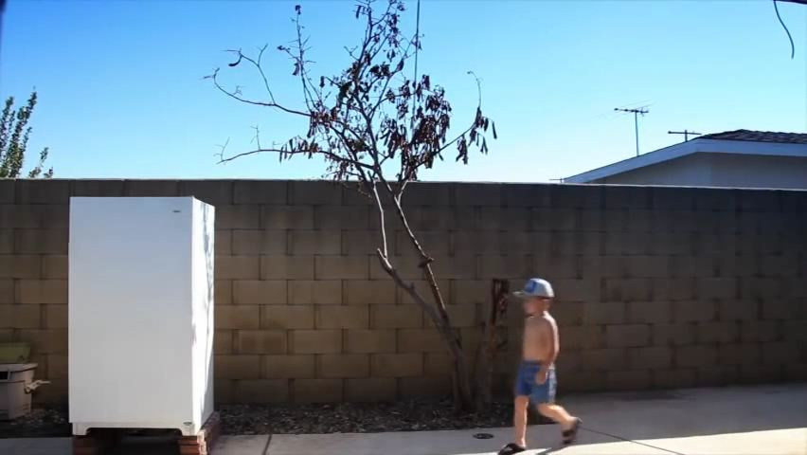
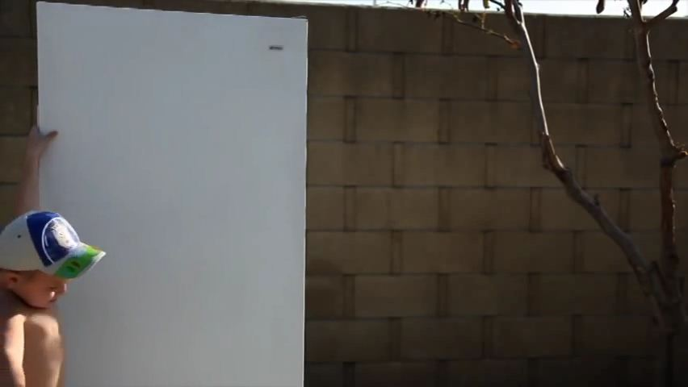
Scene 1.1: Opening the refrigerator hard

Scene 2: Looking at drinks in his favor
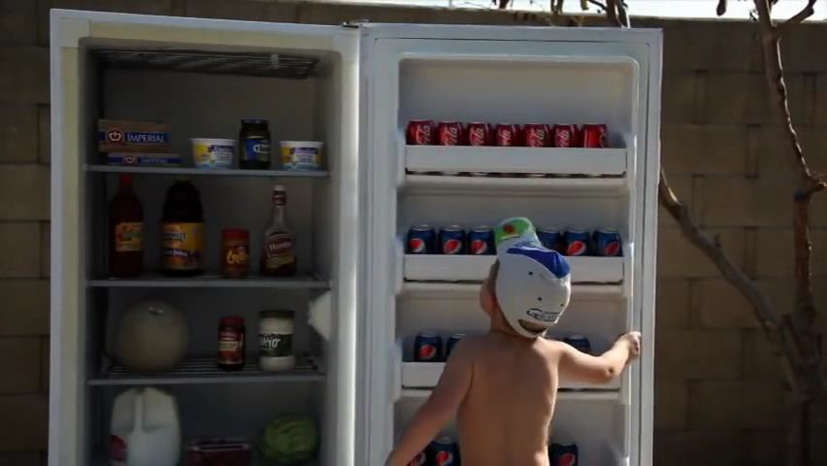
Scene 3 : Having an idea to use Pepsi Can as steps to reach and grab a can of Coca-Cola
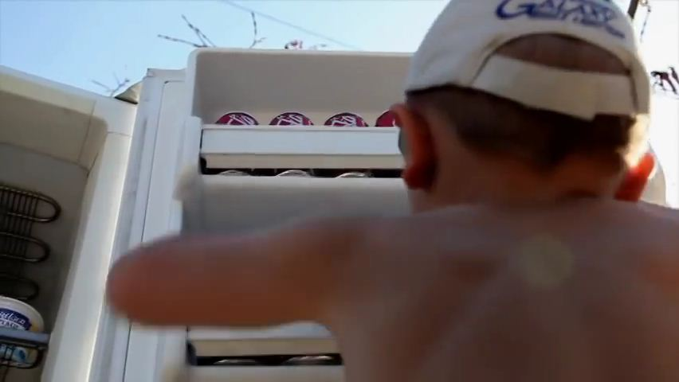

Scene 4: Stepping up the cans of Pepsi for a can of Coca-Cola
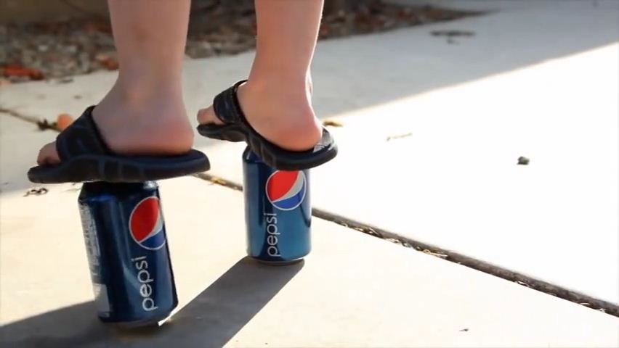

Scene 4.1: Grabbing the can of Coca-Cola
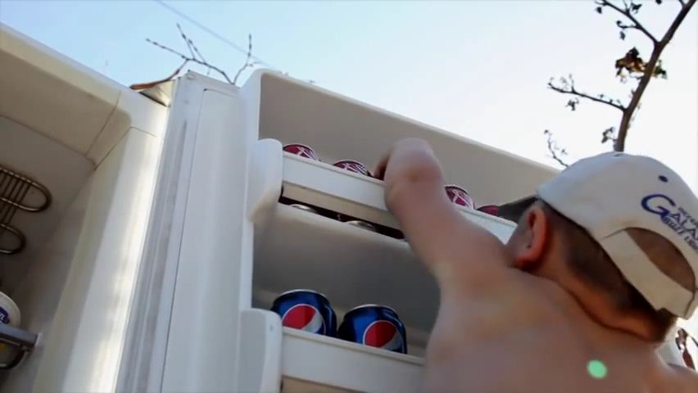
Scene 5: Returning the cans of Pepsi to their initial positions
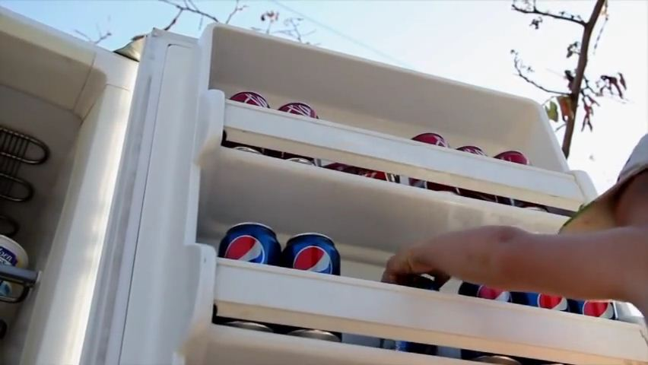

Scene 5.1 : Closing the refrigerator
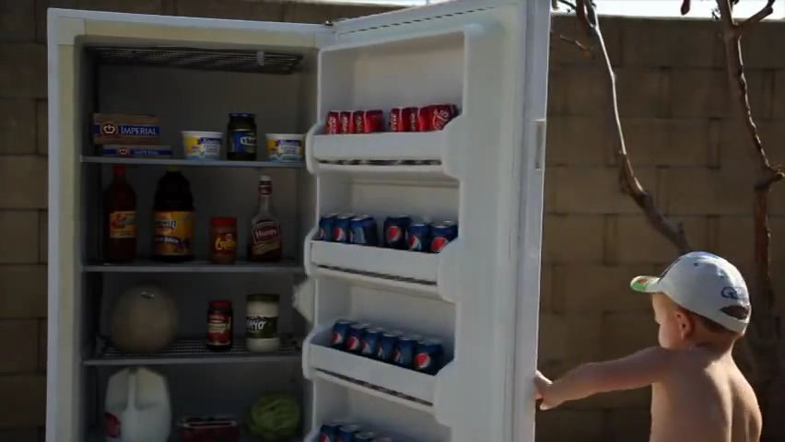
Scene 5.2: About to leave the refrigerator behind with the can of Coca-Cola in his right hand.
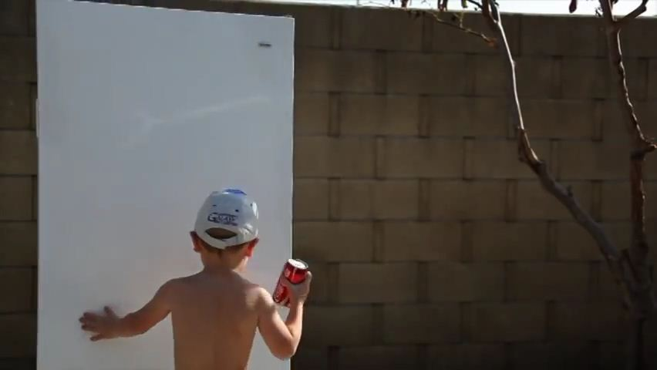

Scene 5.3: Steadily walking away with the can of Coca-Cola
