FACTORS AFFECTING STUDENTS’ WILLINGNESS TO SPEAK ENGLISH AT ELEVENTH GRADE OF SMA PERTIWI MEDAN
Chenny Adela Simamora^{1,} Siti Aisah Ginting²
¹English and Literature Department, Universitas Negeri Medan, Indonesia
²English and Literature Department, Universitas Negeri Medan, Indonesia

ABSTRACT

This study is about Teachers’ Learning Media in Teaching Writing of Descriptive Text at SMP Negeri 37 Medan. The first aim of this research was to know what kinds of learning media are used by teachers in teaching writing of descriptive text and also to analyze the ways of using learning media in teaching writing of descriptive text. The second aim was to know the reasons using learning media in teaching writing of descriptive text by teachers. The data for this study was taken from the teachers who taught in the eight grade in SMP Negeri 37 Medan. The research design of this study was descriptive qualitative research. The data were collected in 3 ways by observing, recording, and interviewing. The data was analyzed based on Harmer (2002) theory. The teachers used kinds of learning media in teaching writing of descriptive text, they were: picture, the overhead projector, and whiteboard. In some cases, teachers also combined two kinds of learning media. The ways of using the learning media in teaching writing of descriptive text, they were: preparation, presentation, and follow-up. The reasons of using learning media by teachers, they were: availability of learning media by school, students’ condition, and students’ interest in used of learning media in the teaching learning process.

ARTICLE INFO
Article History:
Received
Revised
Accepted

Keywords:
Learning Media, Teaching Writing, Descriptive text.

How to Cite: (APA Style)
Name, N. (Year). Title. Jurnal Linguistik Terapan Bahasa Inggris, Vol (Issue), page-page. https://doi.org/10.24114.lt.v18i2.27893

INTRODUCTION
English is one of the most used international languages in communication between nations. This is in accordance with the role of English as a global language as stated by Crystal (2003: 3) that English plays a role as a global or world language because English is learned and used as a means of communication in various countries both as a first language, second language, and as a language. In Indonesia, English is the foreign language studied as a compulsory subject from elementary school to university.
Based on the Decree of the Minister of Education and Culture Number. 060/U/1993 dated 25 February 1993 (Depdikbud, 1993) which describes the possibility of learning English as a local content subject in elementary schools and can be started in the elementary school, junior high school, and senior high school. One of the Indonesian government's efforts to improve English language skill is to introduce English earlier in formal educational institutions, starting from elementary schools. The education community has responded very positively to this policy, it can be seen by the implementation of English language learning in several schools such as kindergarten, elementary, junior high school, senior high school and college levels.
Learning media is a physical form that can be used to convey messages and information. In the world of education, media is one of the important components that can be used by the teacher for teaching. By using media the teacher can deliver the materials easily. Sadiman, et al (2010) stated that media is anything used to send the message from the sender to receiver. Pitriana (2012) stated that media is one of the tools which is used to help the teacher easily for delivering materials to the students. There are some benefits of using media in teaching-learning process. Using media make students, aids students’ retention of knowledge, motivates interest in the subject matter, and illustrates the relevance of many concepts. It is because media is a tool that can convey messages from learning the material to students. Therefore, teachers must choose and appropriate good media in order for the message that is conveyed can be received well by the students.
In learning English there are four aspects of ability, namely listening, speaking, reading, and writing. One aspect that is the focus of research is the aspect of writing skills. Writing is one of the skills in English. According to Nunan (2003) writing is mental work to find ideas, think about how to express them, and organize them into statements and paragraphs that are clear to the reader. Therefore, writing is an activity to produce words from our mind into sentences and paragraphs and involves vocabulary and structure.
Writing is also an important skill for students because writing is an activity to tell what students think in their mind in written words. One of the materials in writing skills is descriptive text. Descriptive text is a text that aims to explain, describe, or describe something. This thing can take the form of anything, be it animals, objects, locations, and so on. And to do that all students need good memory and imagination in writing descriptive texts. Furthermore, teachers must also be more skilled in choosing interesting learning media and in accordance with this writing lesson.
METHOD
The researcher used qualitative research design. According to Bogdan and Biklen (2007) qualitative research has some characteristics, it is included descriptive. The written results of the research contain quotations from the data to illustrate and substantiate the presentation. The data include interview transcripts, field notes, photographs, videotapes, personal documents, and other official records. The data were gathered by observation, interview and documentation. The participants in this research were 2 teachers of SMP Negeri 37 Medan.

FINDINGS
- Kinds of Learning Media Used by Teachers in Teaching Writing of Descriptive Text
According to Harmer, there are 6 types of media namely pictures, the overhead projector, the whiteboard, Bits & Pieces, and The Language Laboratory. Based on the results of observations and interviews by English teachers at SMP Negeri 37 Medan regarding the learning media used in teaching writing descriptive text, there are 3 types of media used by English teachers in the teaching and learning process, they were: pictures, projectors, and whiteboards.
- Picture
The teacher uses the type of image media in teaching writing descriptive text in the classroom. The teacher shows pictures that are presented in the form of slides that have been prepared. During the descriptive text learning process in class VIII- A, each student watched and paid close attention to the pictures displayed by the teacher. The picture displayed by the teacher is a picture of the President of Indonesia Mr. Joko Widodo. The image is obtained from the internet.
- The Overhead Projector
The teacher uses the OHP media type in teaching writing descriptive text in which the projector media must be connected to electricity first. Media Projector used to project images that have been provided. The teacher connects the projector to the laptop to produce an image that will be displayed on the screen. The screen used by the teacher is a white blackboard with no writing on it. The learning media was used by teacher in class VIII-A.
- Whiteboard
The teacher used a whiteboard for teaching writing descriptive text where the whiteboard is available in class.
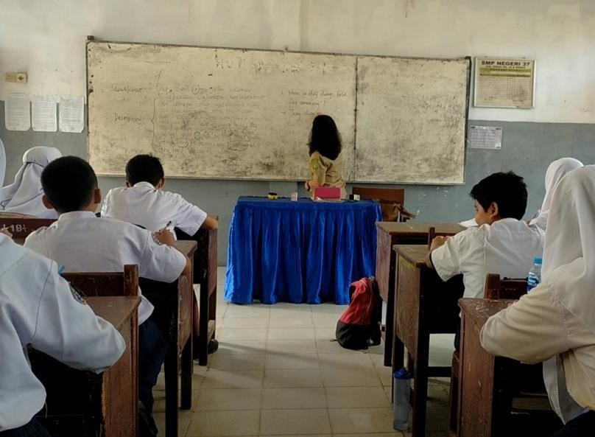

The picture above explains that the whiteboard media used by the teacher in conveying an explanation of the meaning, general structure, and examples of descriptive text, students pay attention to what the teacher writes together.
- The Reason of Using Learning Media
- Teacher 1
Based on interview conducted by the researcher with the first teacher, she stated several reasons for using the learning media used in the descriptive text learning process, namely, the availability of learning media in the classroom such as a whiteboard. Teacher 1 explained that the reason for using the learning media was because the media was already available in class and according to the teacher the media used was simple.
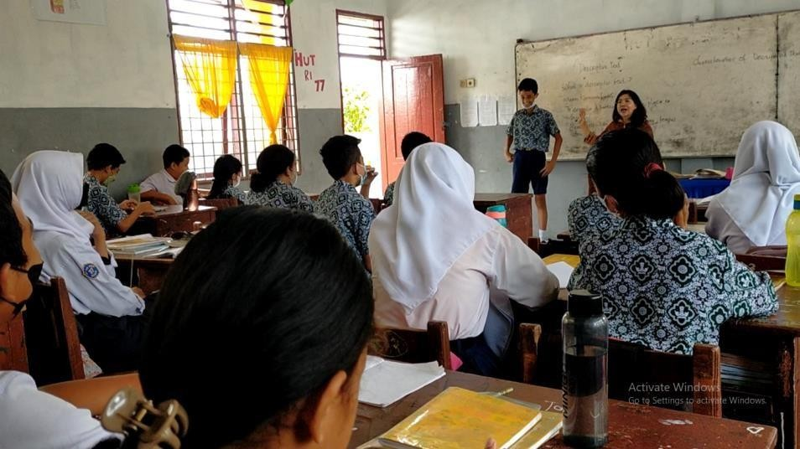

R: Why do you use the board of media to teach descriptive text?
T: Because the purpose of descriptive text is to describe something. So I think it's easier for me to give the examples I mentioned earlier, such as the students themselves, the rooms at this school, or the objects they own, so they can see the comparison or how the description of the object that I show works. And the media I use is already available in class, and I could use the whiteboard as a learning media easily.

The analyzed data sourced from observation and documentation were also supported by the results of interviews conducted with the teachers which were contained in appendix 2.
- Teacher 2
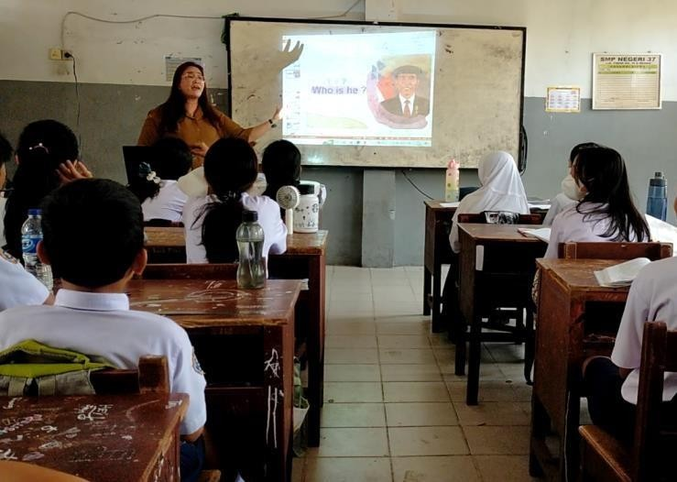
Based on interview conducted by the researcher with the first teacher, she stated several reasons for using the learning media used in the descriptive text learning process, namely, the effectiveness, students’ condition and the availability of projector learning media that had been facilitated by the school. Teacher 2 explained the reasons for using learning media because the media had been provided by the school and the teacher stated that students were very interested in the media used by teacher.
R: Why do you use the board of media to teach descriptive text?

T: Because I can see that students prefer visual media, the media I use in the form of pictures piques according to their interest. And I can also display the image through the projector provided by this school.

The analyzed data sourced from interview conducted with the teacher which were contained in appendix 2.

There were three kinds of learning media used by teachers in teaching descriptive text, namely: pictures, the overhead projector, and whiteboard. These types are by Harmer (2002), namely: 1) Pictures, 2) The Overhead Projector, 3) Board, 4) Bits & Pieces, 5) The Language Laboratory, and 6) Computer. The researcher did not find all the learning media used by the teacher in teaching descriptive text, but in this study, one of the teachers collaborated between two learning media in the learning process such as picture combined with the projector.
In this study, there were also the ways of using learning media in the descriptive text learning process, namely:

Table 4.1 The Ways of Using Learning Media in Teaching Writing
Descriptive Text
No | Teachers | The Ways of Using Learning Media
 |  | Preparation | Presentation | Follow-Up
1. | Omega Sibarani (Teacher 1) | - The teacher greets the students, checks the cleanliness of the classroom.  - The teacher mentioned the title of the learning material and learning objectives. | The teacher explained the material "descriptive text" using a whiteboard. | a) The teacher gives an example of a descriptive text and discusses it with the students.
 |  |  |  | b) The teacher gives assignments to students
2. | Irmawati Simangunsong  (Teacher 2) | - The teacher prepared pictures and projections that will be used as learning media.  - The teacher mentioned the title of the material and the objectives of the lesson. | The teacher explained the descriptive text material using pictures and the overhead projector as the learning media used. | The teacher gave examples of descriptive texts and instructed students to analyze and discuss them together.
There were several teachers’ reason of use the learning media that they used in teaching descriptive text, where teacher 1 was gave the reason that the learning media is already available in the classroom so she does not need to look everywhere. Then, teacher 2 was gave the reasons for using the learning media used by her because students were enthusiastic about paying attention to learning material if the media is in the form of visuals (pictures), the learning media used in the form of a projector is also available at school, so the teacher can use it as a learning media in the classroom.
DISCUSSION
After analyzing the data in the research findings, it can be stated that the data were taken from the teachers who teach in grade eight (VIII-A) and (VIII-E) at SMP Negeri 37 Medan. At this stage, the researcher observed the learning media used by teachers. The data analysis shows that the teachers use 3 types of learning media used by teachers in teaching writing descriptive text in classroom, they were: 1) picture, 2) projector, 3) whiteboard. It was related to Harmer (2002) that classify some types of learning media. They were: 1) picture, 2) The Overhead Projector, 3) Board, 4) Bits and Pieces, 5) The Language Laboratory, 6) Computer.
Teachers used various learning media because seeing the material being taught with the aim of how the material was well. In general, the student's responses toward their teachers’ learning media used in teaching writing descriptive text class were good enough, it could be seen from the material that continued to run according to the lesson plan and students who could still follow it and passionate.
As stated by Harmer (2002) revealed that there are six types of learning media, namely: 1) picture and image, 2) The Overhead Projector, 3) Board, 4) Bits & Pieces, 5) The Language Laboratory 6) Computers but teachers at SMP N 37 Medan only uses 3 types in teaching descriptive text, namely: picture, the overhead projector, and board because in choosing learning media the teacher is always available and the school conditions are in the learning process. In some cases the teacher found that there were several obstacles in the use of learning media, namely if the electricity went out the teacher used the projector learning media unable to display the picture, so the teacher had prepared printed picture that would be used as learning media in teaching descriptive text. It was about implementation activities. As one of the previous studies related to this research, Damayanti (2015) investegated the weaknesses of the English learning media used by teacher, including: content, training activities, implementation activities, and available images.
By using the learning media, the participant or students explain that learning process is effective and efficient in terms of time, they said that pictures can help them in practicing their imagination skills, obtaining new ideas, and increasing their understanding of descriptive text material.
As stated by Musfiqon (2016) revealed that there are five the reason for using learning media, namely: 1) Usability of the Media, 2) Students' Condition, 3) Availability of the Media, 4) Teachers' skill to Using Media, 5) Technical quality. From research findings, there were some several teachers’ reason of use the learning media that they used in teaching descriptive text, where teacher 1 was gave the reason that the learning media is already available in the classroom so she does not need to look everywhere. Then, teacher 2 was gave the reasons for using the learning media used by her because students were enthusiastic about paying attention to learning material if the media is in the form of visuals (pictures), the learning media used in the form of a projector is also available at school, so the teacher can use it as a learning media in the classroom.

CONCLUSION
After describing and analyzing the data, the researcher draws conclusions about the factors that affect students' willingness to speak in English. The results showed that there were the kinds of learning media based on the research findings and discussion, it could be drown the conclusion that the teachers used learning media in teaching writing descriptive text, they were: picture, projector, and whiteboard. It was found that teacher used learning media during teaching-learning process. The teachers stated several reasons for using the learning media used in the descriptive text learning process, namely: usability of the learning media used by teachers, the effectiveness, and the availability of projector and whiteboard as learning media that had been facilitated by the school.

REFERENCES
Anderson, Mark, and Anderson Kathy. 2003. Text Types in English. Australia: Mac Milan Education.
Aini, Yulia Isratul. 2018. The Use Of Google Classroom As An English Learning Media. Journal of English Education and Linguistics. Indonesia: Vol 2(1). Desember 2018.
Arsyad, Azhar. 2006. Learning Media. Jakarta: Raja Grafindo Persada.
Biddle, Bruce. J. and Peter, H. Rossi. 1966. Educational Media, Education & Society(ed.).
Bogdan, Robert C., Biklen, Sari Knopp. 2007. Qualitative Research for Education: An Introduction to Theory and Methods. United State of America. Pearson Education Inc. 5th Edition
Brown,et.al. 1977. Audio Visual Instruction: Technology, Media and Methods. New York: Mc.Graw Hill Book.
Damayanti, Sri. 2015. English Learning Media at Smp Negeri 8 Palopo. Ethical Lingua. Indonesia: Vol 2(2). Agustus 2015.Educational Media, Education and Society. Chicago: Aldine publishing.
D, Angelo, Frank J, 1980. Process and Thought in Composition Massachusetts: Winthorp Publishers, Inc.
Gerlach, V.s., Elly, D.P. 1980. Teaching and Media: a Systematic Approach. New Jersey: Prentice
Hall.Inc. Gronlund, Norman E. 1976. Measurement and Evaluation in Teaching.
New York: Macmillan Publishing Co.
Harmer, Jeremy. 2001. How to Teach Writing. Longman: Pearson Limited Education.
Karimah, Nadya. 2016. Teaching Writing of Descriptive Text. Jakarta.
Miarso, Y. (2009). Sowing Educational Technology. Jakarta: Kencana Prenada Media Group.
Musfiqon. (2012). Development of Learning Media and Sources. Jakarta: Prestasi Pustakaraya.
Puspitarini, et al. 2019. Using Learning Media to Increase Learning Motivation in Elementary School. Anatolian Journal of Education. Indonesia: Vol 4(2). Oktober 2019.
Sukartiwi, (1995). Monitoring dan Evaluasi Proyek Pendidikan. Jakarta: Pustaka Jaya

