# **APPENDIX I**

## **Lesson Plan Control Class**

Name of School: SMP 14 KOTA TANGERANG

Subject: English Language

Class/Semester: 9A / I

Time allocation: 40 minutes (2x meeting)

Material: Narrative Text (Short Story)

Skill: Reading

Basic Competence:

K1: Expressing meaning in narrative text using story mapping in embody components of reading acts: fluent, accuracy, pronunciation, vocabulary, and intonation

K2: apply oral social functions and involve actions of past events in accordance with the linguistic elements of use.

**Core Competencies:**

1. Respect and appreciate other religious
2. Demonstrate honesty, discipline, responsibility, courtesy, self-confidence.
3. Understanding knowledge (factual, conceptual, and procedural) based on their curiosity about science, technology, art, culture related to visible phenomena and event.

Learning Objective

At the end of the lesson, student can respond to the oral question teacher gave:

1. Answer the definition of narrative text
2. Answer the purpose material of the narrative text
3. Describe the activities today

**Learning Activity:**

|  |  |
| --- | --- |
| **Activities** | **Description of activities** |
| Pre activities | - Saying hello and pray.  - Provide motivation and apperception.  - Inform learning objectives to students |
| Main activities | - Students reading aloud a short story entitled "Snow white" which is given to the teacher  - Students mention all the characters that appear, good characters and bad characters, the theme of the story, the location of the story.  - Students listen to narrative text material through power point  - Students determine the social function of narrative texts in the form of short stories  - Students analyze the structure of narrative texts in short stories  - Students find the feature language of narrative texts in the form of short stories  - Students make resumes and answer multiple choice test |
| Post activities | - Students give answer papers to the teacher  - Students present the results of the resume  - Students discuss and ask questions about the results of student resumes  - provide feedback on the learning process and results  - inform the plan of learning activities for the next |

**Learning Media:**

1. Internet
2. Student Handbooks

**Learning methods:**

Method: Leaturing Method

**Learning Resources:**

1. Power Point / Learning Videos
2. Narrative text from the internet

**Assessment:**

1. Technique of assessment = Test
2. Form of instrument = Reading the short story and answer multiple choice test

|  |  |
| --- | --- |
| **Exploration for students** | **Exploration for teachers** |
| - Students prepare to explore the information they need and formulate problems  - Dig up information by reading, discussing, or experimenting  - Collect and process data  - Developing information search results in the form of graphs, tables, diagrams  - Identify difficult vocabulary related in short stories. Example: about the use of nouns, verbs, personal pronouns, gambits and adverbs. | - Using a variety of approaches and media  - Facilitating interaction between students, students with teachers, and students with learning resources  - Involve students actively  – Involve students in seeking broad and deep information about the topic/theme of the material being study  – Using a variety of learning approaches, learning media, and other learning resources  - Facilitate interaction between students and between students and teachers, the environment, and other learning resources  – Involve students actively in every learning activity |
| **Elaboration for students** | **Elaboration for teacher** |
| - Report the results of exploration orally in reading, both individually and in groups  - Respond to reports or opinions of friends  - Argue politely  - Discuss and hold Q&A  - Analyze the strength or weakness of the argument  - Conclude together, and compile reports or writings,  - Present their findings for discussion | - Facilitate students to think critically, analyze, solve problems, act without fear  - Facilitating students through giving assignments, discussions, and others to come up with new ideas both orally and in writing  - Facilitate students to compete in a healthy and honest manner  - The teacher looks at the students' work and discusses the questions that are considered difficult  - Acts as resource person and facilitator to explain questions from students  - Provide positive feedback to students and reinforcement in the form of oral, written, gestures, and prizes for student success |

**Learning steps**

1. **Observe**

In observing activities, the teacher opens wide and variation opportunities for students to make observations through activities: seeing, listening, and reading. The teacher facilitates students to make observations, and trains them to pay attention (see, read, hear) to the important things of an object or object.

1. **Collect and associate**

Gather information from various sources in various ways. For that reason, students can read more books, from these activities, several pieces of information are collect. This information becomes the basis for the next activity, namely processing information to find the relationship between one information and another, finding patterns from the information linkages and even drawing conclusions from the patterns found.

1. **Communicating results**

The next activity is to write or tell what is found in the activity of seeking information, associating and finding patterns. These results are present in class and assessing by the teacher as the learning outcomes of students or groups of students.

1. **Closing**

In the closing activity, the students make a summary/conclusion of the material obtain during the learning process and the teacher re-explains the material being taught to strengthen student memory.

Tangerang,15 February 2024

English Teacher Researcher

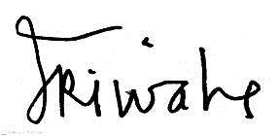 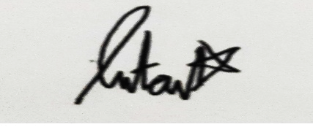

**(Sri Wahyuni) (Intan Puspita Salma)**

NIP. 196304241985032012

## **Test I (Pre-Test)**

Once upon a time, there was a beautiful princess named Snow White. She was kind and gentle and a friend to all animals. One day, Snow White met a charming prince. As they sang a song of love together, Snow White's evil stepmother, the Queen, watched them. The Queen was so jealous of Snow White's beauty that she ordered her Huntsman to kill the young princess. But the Huntsman couldn't bring himself to hurt Snow White. He told her to run far away so the Queen would never find her.

Snow White ran deep into the woods. She was lost and scared but soon found herself in front of a cottage. The princess knocked, but no one was home. She slowly stepped inside. The cottage was a mess! With the help of her forest friends, Snow White cleaned every nook and cranny. "Maybe whoever lives here will let me stay," said Snow White. Upstairs, Snow White found seven little beds. She thought they belonged to children. Tired from cleaning, Snow White yawned as she curled up on the beds and fell asleep.

Meanwhile, the Seven Dwarfs were heading home from a long day of working in a jewel mine. They were anxious to get home to their cottage in the woods. The Seven Dwarfs were surprised when they found a princess inside their home! When Snow White awoke, she was charmed by the Seven Dwarfs: Dopey, Sneezy, Happy, Grumpy, Doc, Bashful, and Sleepy. The Dwarfs wanted to protect the beautiful princess from the evil queen, so they invited Snow White to live with them. To celebrate, the new friends sang and danced the night away. Back at the castle, the Queen learned that Snow White was still alive. Enraged, she made a magic potion to change her appearance. Her plan was to trick the princess.

After the Dwarfs had set off for work the next day, the Queen, disguised as an old peddler woman, offered Snow White a beautiful red apple. Snow White took one bite of the apple and fell into a deep sleep. The Queen had poisoned her! When the Dwarfs came home, they chased the Queen to the top of a stormy mountain. Suddenly, lightning hit the mountain, and the Queen fell, never to be seen again. But Snow White was still in a deep sleep.

The Seven Dwarfs kept watch over her day and night. Finally, Snow White's Prince Charming arrived. He had been searching everywhere for the beautiful princess he had sung with so long ago. Finally, Snow White's Prince Charming arrived. He had been searching everywhere for the beautiful princess he had sung with so long ago. The Prince awakened Snow White with Love's First Kiss. The spell was broken! Snow White and the Prince returned to the kingdom and lived happily ever after.

**A. Answer the question below**

1. What is the Main Idea of the story?
2. Snow White ran deep into the woods. She was lost and scared but soon found herself in front of a cottage
3. The Prince awakened Snow White with love's first kiss
4. There was a beautiful princess named Snow White and the queen was so jealous of Snow White's beauty
5. The Queen had poisoned Snow white
6. What is the topic of the story?
7. The Stepmother who hates Snow White's attitude
8. The jealous stepmother of Snow White's beauty
9. The Stepmother jealous of Snow White's friendship
10. The Stepmother who jealous toward Snow White's intelligence
11. What is the theme of story Snow White?
12. Horror
13. Fairytales
14. Legends
15. Romance
16. What the second paragraph talk about?
17. Stepmother Snow White made a magic potion to change her appearance
18. Snow White met prince charming when they sang a song
19. Snow White run far away from the queen
20. Prince awakened Snow White with love's first kiss
21. Which the following does not include in the passage of story?
22. Snow White Stepmother offered Snow White a beautiful red apple.
23. There seven dwarfs who lives in the cottage
24. Huntsman killed Snow White
25. Prince awakened Snow White with love's first kiss
26. Why did her stepmother want to give poison to Snow white?
27. Snow White stepmother hate song that Snow White sings
28. Snow White stepmother hate anyone more beautiful than herself
29. Snow White stepmother hate Snow White have many friends
30. Snow White stepmother hate animal that always approach Snow White
31. Why did the huntsman tell Snow White to go far away?
32. Huntsman afraid with Snow White
33. Huntsman not the kind of person who can kill Snow White, And then he told the truth that her stepmother had bad intentions toward Snow White.
34. Huntsman just wanted to convey the information told by her stepmother that Snow White should go home before nightfall
35. The Huntsman afraid with the prince
36. What did the dwarves do when Snow White at their house?
37. Dwarfs allow Snow White to stay but with some requirement
38. Dwarfs chase away Snow White from their home
39. Dwarfs want to protect Snow White after hear Snow White's story
40. Dwarfs not allow Snow White to stay because their room already full
41. What did the dwarf do when they found out that Snow White was poisoned by her stepmother?
42. The Dwarfs chase stepmother up to the hill
43. The Dwarfs call the prince for help
44. The Dwarfs just waiting for Snow White to wake up without doing anything
45. The Dwarfs pick up weapons on arsenal
46. What did prince do to save Snow white from the deep sleep?
47. Prince give green apple juice to healing Snow White
48. Prince ask animal to healing Snow White
49. The Prince prays to God to wake up Snow White
50. Prince wake up Snow White with love magic
51. Where did Snow White run to protect herself?
52. Village
53. Mountain
54. Forest
55. Park
56. From the passage we learn that the cottage was
57. In the lake
58. In the woods
59. In the valley
60. In the village
61. **They** were anxious to get home to their…(paragraph 22)

What does the bold word refer to?

1. Prince
2. Huntsman
3. Dwarfs
4. Snow White’s stepmother
5. **Her** plan was to trick the…(Paragraph 7)

What does the bold word refer to?

1. Huntsman
2. Snow White
3. The Queen
4. Prince
5. What is the purpose of the text?
6. To inform about Snow White and her stepmother
7. To give information that the prince looked for the real princess
8. To amuse the reader with the story of Snow White and her stepmother
9. To describe how Snow White could feel meeting the prince in dwarfs’ house
10. What moral value can we learn from the story?
11. Beauty doesn’t justify your mean attitude
12. Wonderful to talk to strangers
13. Beauty leads to destruction
14. Jealous leads to destruction
15. Choose the correct sentence that describe the Orientation in Snow White Story
16. The spell was broken! Snow White and the prince returned to the kingdom and lived happily ever after
17. Finally, Snow White's prince charming arrived. He had been searching everywhere for the beautiful princess he had sung with so long ago. The Prince awakened Snow White with love's first kiss
18. Once upon a time, there was a beautiful princess named Snow White. She was kind and gentle and a friend to all animals
19. After the dwarfs had set off for work the next day, the queen, disguised as an old peddler woman, offered Snow White a beautiful red apple. Snow White took one bite of the apple and fell into a deep sleep
20. Choose the correct sentence that describe the Complication in Snow White Story
21. After the dwarfs had set off for work the next day, the queen, disguised as an old peddler woman, offered Snow White a beautiful red apple. Snow White took one bite of the apple and fell into a deep sleep
22. The spell was broken! Snow White and the prince returned to the kingdom and lived happily ever after
23. Once upon a time, there was a beautiful princess named Snow White. She was kind and gentle and a friend to all animals
24. Finally, Snow White's prince charming arrived. He had been searching everywhere for the beautiful princess he had sung with so long ago. The Prince awakened Snow White with love's first kiss
25. Choose the correct sentence that describe the Resolution in Snow White Story
26. Once upon a time, there was a beautiful princess named Snow White. She was kind and gentle and a friend to all animals
27. The spell was broken! Snow White and the prince returned to the kingdom and lived happily ever after
28. After the dwarfs had set off for work the next day, the queen, disguised as an old peddler woman, offered Snow White a beautiful red apple. Snow White took one bite of the apple and fell into a deep sleep
29. Finally, Snow White's prince charming arrived. He had been searching everywhere for the beautiful princess he had sung with so long ago. The Prince awakened Snow White with love's first kiss
30. Choose the correct sentence that describe the Re-orientation in Snow White Story
31. The spell was broken! Snow White and the prince returned to the kingdom and lived happily ever after
32. After the dwarfs had set off for work the next day, the queen, disguised as an old peddler woman, offered Snow White a beautiful red apple. Snow White took one bite of the apple and fell into a deep sleep
33. Once upon a time, there was a beautiful princess named Snow White. She was kind and gentle and a friend to all animals
34. Finally, Snow White's prince charming arrived. He had been searching everywhere for the beautiful princess he had sung with so long ago. The Prince awakened Snow White with love's first kiss

**Assessment Test**

-20 Multiple Choice

SMC= Correct number : 2

|  |  |
| --- | --- |
| **Question Item** | **Total Score** |
| **1-20** | 100 |
| **-** All question correct | 1 |
| **-** All question not correct | 0 |

## **Lesson Plan Experimental Class**

Name of School: SMP 14 KOTA TANGERANG

Subject: English Language

Class/Semester: 9B / I

Time allocation: 40 minutes (2x meeting)

Material: Narrative Text (Short Story)

Skill: Reading

Basic Competence:

K1: Expressing meaning narrative text using story mapping in embody component of reading acts.

K2: Develop a story mapping strategy by paying attention to the correct text structure and linguistic elements according to the context.

**Core Competencies:**

1. Respect and appreciate other religious
2. Demonstrate honesty, discipline, responsibility, courtesy, self-confidence.
3. Understanding knowledge (factual, conceptual, and procedural) based on their curiosity about science, technology, art, culture related to visible phenomena and event.

Learning Objective

At the end of the lesson, student can respond to the oral question teacher gave:

1. Answer the definition of narrative text
2. Answer the purpose material of the narrative text
3. Describe the activities today

**Learning Activity:**

|  |  |
| --- | --- |
| **Activities** | **Description of activities** |
| Pre activities | -Saying hello and pray.  -Provide motivation and apperception.  -Inform learning objectives to students |
| Main activities | - Students reading aloud a short story entitled "Rapunzel" which is given to the teacher  - Students mention all the characters that appear, good characters and bad characters, the theme of the story, the location of the story.  - Students listen to narrative text material through power point  - Students determine the social function of narrative texts in the form of short stories  - Students analyze the structure of narrative texts in short stories  - Students find the features language of narrative texts in the form of short stories  - Students make story mapping and answer multiple choice test |
| Post activities | -Students give answer papers to the teacher  - Students present the results of their work  - Students discuss and ask questions about the results of student resumes  - provide feedback on the learning process and results  - inform the plan of learning activities for the next |

**Learning Media:**

1. Internet
2. Student Handbooks

**Learning methods:**

Method: Story Mapping

**Learning Resources:**

1. Power Point / Learning Videos
2. Narrative text from the internet

**Assessment:**

1. Technique of assessment = Test
2. Form of instrument = Reading the short story and answer multiple choice test

|  |  |
| --- | --- |
| **Exploration for students** | **Exploration for teachers** |
| - Students prepare to explore the information they need and formulate problems  - Dig up information by reading, discussing, or experimenting  - Collect and process data  - Developing information search results in the form of graphs, tables, diagrams  - Identify difficult vocabulary related in short stories. Example: about the use of nouns, verbs, personal pronouns, gambits and adverbs.  Teacher  - Using a variety of approaches and media  - Facilitating interaction between students, students with teachers, and students with learning resources  - Involve students actively  – Involve students in seeking broad and deep information about the topic/theme of the material being study  – Using a variety of learning approaches, learning media, and other learning resources  - Facilitate interaction between students and between students and teachers, the environment, and other learning resources  – Involve students actively in every learning activity | - Using a variety of approaches and media  - Facilitating interaction between students, students with teachers, and students with learning resources  - Involve students actively  – Involve students in seeking broad and deep information about the topic/theme of the material being study  – Using a variety of learning approaches, learning media, and other learning resources  - Facilitate interaction between students and between students and teachers, the environment, and other learning resources  – Involve students actively in every learning activity |
| **Elaboration for students** | **Elaboration for teacher** |
| - Report the results of exploration orally in reading, both individually and in groups  - Respond to reports or opinions of friends  - Argue politely  - Discuss and hold Q&A  - Analyze the strength or weakness of the argument  - Conclude together, and compile reports or writings,  - Present their findings for discussion | - Facilitate students to think critically, analyze, solve problems, act without fear  - Facilitating students through giving assignments, discussions, and others to come up with new ideas both orally and in writing  - Facilitate students to compete in a healthy and honest manner  - The teacher looks at the students' work and discusses the questions that are considered difficult  - Acts as resource person and facilitator to explain questions from students  - Provide positive feedback to students and reinforcement in the form of oral, written, gestures, and prizes for student success |

**Learning steps**

1. **Observe**

In observing activities, the teacher opens wide and variation opportunities for students to make observations through activities: seeing, listening, and reading. The teacher facilitates students to make observations, and trains them to pay attention (see, read, hear) to the important things of an object or object.

1. **Collect and associate**

Gather information from various sources in various ways. For that reason, students can read more books, from these activities, several pieces of information are collect. This information becomes the basis for the next activity, namely processing information to find the relationship between one information and another, finding patterns from the information linkages and even drawing conclusions from the patterns found.

1. **Communicating results**

The next activity is to write or tell what is found in the activity of seeking information, associating and finding patterns. These results are present in class and assessing by the teacher as the learning outcomes of students or groups of students.

1. **Closing**

In the closing activity, the students make a summary/conclusion of the material obtain during the learning process and the teacher re-explains the material being taught to strengthen student memory.

Tangerang,15 February 2024

English Teacher Researcher

 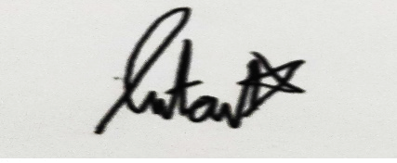

**(Sri Wahyuni) (Intan Puspita Salma)**

NIP. 196304241985032012

## **Test II (Post-Test)**

Long ago, a king and queen had a baby daughter named Rapunzel. What her devoted parents didn’t know was that Rapunzel’s golden hair contained magical healing powers. A selfish old woman named Mother Gothel knew of the magic in Rapunzel’s hair and wanted it to keep herself young. So she kidnapped the baby and raised her in a tower deep in the woods, never telling her that she was a princess.

As Rapunzel’s hair grew and grew, she loved gazing out the tower window at the lights that floated in the night sky every year on her birthday. She longed to leave the tower and see them up close, but Mother Gothel refused. Meanwhile, a young thief named Flynn Rider had stolen something special from the King’s castle, and the royal guards were after him. Suddenly, he saw the perfect hiding place—a tower! When Flynn Rider climbed into the tower,

Rapunzel knocked him out with a frying pan. Then she secretly inspected the satchel he carried. Inside, Rapunzel found a sparkling gold object. It was so familiar. Flynn Rider awoke and found himself tied to a chair with Rapunzel's long, golden hair. Rapunzel pointed to her painting of the floating lights. Tomorrow was her eighteenth birthday. If Flynn took her to see the lights, she’d return his satchel. After Flynn agreed to help, Rapunzel used her hair to climb down from the tower. She'd never been outside before! But when her feet touched the grass, Rapunzel nearly burst with excitement, exclaiming, “Woo-hoo!”

Rapunzel and Flynn enjoyed their adventure, but they were being chased! Mother Gothel was looking for them. The royal guards were after Flynn, and so were his angry partners in crime. They wanted the crown! Days passed, and Rapunzel and Flynn managed to escape their pursuers. One morning, Rapunzel saw a breathtaking sight: a beautiful kingdom with a castle sitting high above. She headed straight to it! In the town, Rapunzel was drawn to a painting of the King, the Queen, and their baby, who was known as the lost princess. The child had golden hair and green eyes... just like her!

Flynn rowed Rapunzel out to view the floating lights, which were actually lanterns! Flynn gave Rapunzel her own lantern to send into the night, and she returned the crown. Then the couple gazed into each other's eyes. They were falling in love. Later, Flynn and Rapunzel were separated. Mother Gothel told Rapunzel that Flynn had only wanted the crown. But she realized Mother Gothel was lying! Rapunzel now knew that she was the lost princess! Suddenly, Flynn arrived to rescue Rapunzel! But Mother Gothel hurt him badly.

She wanted Rapunzel to stay with her forever. If she did, she’d allow Rapunzel to heal Flynn. But before Rapunzel could act, Flynn cut off her hair, which lost its magic. Without the magic, Mother Gothel quickly aged and turned to dust. Rapunzel was now free, but Flynn was dying. “You were my new dream,” he whispered. One of Rapunzel’s tears fell on Flynn and began to glow... and healed him! Flynn brought Rapunzel back to the castle. The King and Queen rushed to embrace their lost princess. That night, the entire kingdom celebrated her return by launching hundreds of lanterns—the lights that had guided her home.

**B. Answer the question below.**

1. What the main idea of story Rapunzel?
2. Rapunzel longed to leave the tower and see floated light up close
3. Rapunzel and Flynn enjoyed their adventure
4. King and Queen didn’t know that Rapunzel’s golden hair contain magical healing powers.
5. Flynn Rider had stolen something special from the king’s castle
6. What is the topic of the story?
7. Mother Gothel kidnapped Rapunzel because have a grudge against the king and queen
8. Mother Gothel kidnapped Rapunzel because felt lonely in the tower
9. Mother Gothel kidnapped Rapunzel to keep young appearance
10. Mother Gothel kidnaps Rapunzel to get treasure from king and queen
11. What is the theme of story Rapunzel?
12. Legends
13. Horror
14. Fairytales
15. Myth
16. What the second paragraph tells about?
17. Mother Gothel forbids Rapunzel to go outside
18. Rapunzel has found a painting just look like her in town
19. Flynn plans to take Rapunzel away from Mother Gothel
20. Rapunzel gives Flynn requirement to take Rapunzel out of the tower if Flynn wants his bag back
21. Which the following does not include in the passage of story?
22. Rapunzel cancels to go outside tower with Flynn
23. Rapunzel not believe Mother Gothel after seeing a painting in town
24. Rapunzel saves Flynn from Mother Gothel's stab
25. Rapunzel asks permission to go outside to see the flying lights
26. Why Rapunzel live in the tower?
27. Mother Gothel only wanted the crown
28. Rapunzel wanted it to keep herself young
29. Mother Gothel kidnapped the baby and raised her in a tower deep in the woods, never telling Rapunzel that she was a princess
30. Rapunzel was drawn to a painting of the king, the queen, and their baby
31. What does the magic golden hair can do?
32. Rapunzel’s golden hair can float
33. Rapunzel’s golden hair contained magical healing powers
34. Rapunzel’s golden hair can shape as weapon
35. Rapunzel’s golden hair contained invisible powers
36. What does Rapunzel want from Mrs. Gothel on her birthday?
37. Wanted the crown
38. Want to see a painting of the king, the queen, and their baby
39. Longed to leave the tower and see the lights that floated in the night sky
40. Want to touch the grass
41. What is Flynn Rider doing in the tower where Rapunzel lives?
42. Flynn try to kidnap his pursuers in Rapunzel tower
43. Hiding after stolen something special from the king’s castle
44. Flynn rowed Rapunzel out to view the floating lights
45. Want to see a painting of the king, the queen, and their baby
46. What did Rapunzel do when she found out someone had infiltrated in the tower?
47. Rapunzel knocked Flynn with a frying pan
48. Pointed her painting of the floating lights to Flynn
49. Rapunzel climb down from the tower used her hair
50. Rapunzel nearly burst with excitement
51. What happens when Mrs. Gothel finds out Rapunzel is not in the tower?
52. Mother Gothel kick Rapunzel out of the tower
53. Mother Gothel ask Rapunzel not to play outside until evening
54. Mother Gothel warn Rapunzel that Flynn not a good person
55. Mother Gothel ask Flynn to take care Rapunzel
56. From the passage we learn that the tower was
57. In the village
58. In the valley
59. In the woods
60. In the lake
61. **He** saw the perfect hiding place…(Paragraph 3)

What does the bold word refer to?

1. Flynn
2. Royal Guard
3. The king
4. Mother Gothel
5. Then **she** secretly inspected…(Paragraph 9)

What does the bold word refer to?

1. Mother Gothel
2. Royal Guard
3. Rapunzel
4. Flynn
5. What moral value can we learn from the story?
6. Forgive yourself
7. Kindness toward all
8. We must disobendent to our parents
9. Take a step out of your comfort zone
10. What is the purpose of the writer by writing the story above?
11. To describe Rapunzel and Mother Gothel relationship
12. To entertain the readers of Rapunzel’s story
13. To tell Rapunzel’s relationship with Flynn
14. To narrate how the royal guard finds the princess
15. Choose the correct sentence that describe the Orientation in Rapunzel Story
16. A selfish old woman named Mother Gothel knew of the magic in Rapunzel’s hair and wanted it to keep herself young. So she kidnapped the baby and raised her in a tower deep in the woods, never telling her that she was a princess
17. Suddenly, Flynn arrived to rescue Rapunzel! But Mother Gothel hurt him badly. She wanted Rapunzel to stay with her forever. If she did, she’d allow Rapunzel to heal Flynn. But before Rapunzel could act, Flynn cut off her hair, which lost its magic. Without the magic, Mother Gothel quickly aged and turned to dust. Rapunzel was now free, but Flynn was dying. “You were my new dream,” he whispered. One of Rapunzel’s tears fell on Flynn and began to glow... and healed him!
18. Long ago, a king and queen had a baby daughter named Rapunzel. What her devoted parents didn’t know was that Rapunzel’s golden hair contained magical healing powers
19. Flynn brought Rapunzel back to the castle. The King and Queen rushed to embrace their lost princess. That night, the entire kingdom celebrated her return by launching hundreds of lanterns—the lights that had guided her home
20. Choose the correct sentence that describe the Complication in Rapunzel Story
    1. A selfish old woman named Mother Gothel knew of the magic in Rapunzel’s hair and wanted it to keep herself young. So she kidnapped the baby and raised her in a tower deep in the woods, never telling her that she was a princess
    2. Suddenly, Flynn arrived to rescue Rapunzel! But Mother Gothel hurt him badly. She wanted Rapunzel to stay with her forever. If she did, she’d allow Rapunzel to heal Flynn. But before Rapunzel could act, Flynn cut off her hair, which lost its magic. Without the magic, Mother Gothel quickly aged and turned to dust. Rapunzel was now free, but Flynn was dying. “You were my new dream,” he whispered. One of Rapunzel’s tears fell on Flynn and began to glow... and healed him!
    3. Long ago, a king and queen had a baby daughter named Rapunzel. What her devoted parents didn’t know was that Rapunzel’s golden hair contained magical healing powers
    4. Flynn brought Rapunzel back to the castle. The King and Queen rushed to embrace their lost princess. That night, the entire kingdom celebrated her return by launching hundreds of lanterns—the lights that had guided her home
21. Choose the correct sentence that describe the Resolution in Rapunzel Story
    1. A selfish old woman named Mother Gothel knew of the magic in Rapunzel’s hair and wanted it to keep herself young. So she kidnapped the baby and raised her in a tower deep in the woods, never telling her that she was a princess
    2. Suddenly, Flynn arrived to rescue Rapunzel! But Mother Gothel hurt him badly. She wanted Rapunzel to stay with her forever. If she did, she’d allow Rapunzel to heal Flynn. But before Rapunzel could act, Flynn cut off her hair, which lost its magic. Without the magic, Mother Gothel quickly aged and turned to dust. Rapunzel was now free, but Flynn was dying. “You were my new dream,” he whispered. One of Rapunzel’s tears fell on Flynn and began to glow... and healed him!
    3. Long ago, a king and queen had a baby daughter named Rapunzel. What her devoted parents didn’t know was that Rapunzel’s golden hair contained magical healing powers
    4. Flynn brought Rapunzel back to the castle. The King and Queen rushed to embrace their lost princess. That night, the entire kingdom celebrated her return by launching hundreds of lanterns—the lights that had guided her home
22. Choose the correct sentence that describe the Re-orientation in Rapunzel Story
23. A selfish old woman named Mother Gothel knew of the magic in Rapunzel’s hair and wanted it to keep herself young. So she kidnapped the baby and raised her in a tower deep in the woods, never telling her that she was a princess
24. Suddenly, Flynn arrived to rescue Rapunzel! But Mother Gothel hurt him badly. She wanted Rapunzel to stay with her forever. If she did, she’d allow Rapunzel to heal Flynn. But before Rapunzel could act, Flynn cut off her hair, which lost its magic. Without the magic, Mother Gothel quickly aged and turned to dust. Rapunzel was now free, but Flynn was dying. “You were my new dream,” he whispered. One of Rapunzel’s tears fell on Flynn and began to glow... and healed him!
25. Long ago, a king and queen had a baby daughter named Rapunzel. What her devoted parents didn’t know was that Rapunzel’s golden hair contained magical healing powers
26. Flynn brought Rapunzel back to the castle. The King and Queen rushed to embrace their lost princess. That night, the entire kingdom celebrated her return by launching hundreds of lanterns—the lights that had guided her home

**Assessment Rubric**

-20 Multiple Choice

SMC= Correct number : 2

|  |  |
| --- | --- |
| **Question Item** | **Total score** |
| **1-20** | 100 |
| **-** All question correct | 1 |
| **-** All question not correct | 0 |

## **The Validity Test**

Content Outline

Class/Semester: 9/2

Number of question: 20

Form of question: Multiple Choice

|  |  |
| --- | --- |
| **Basic Competence** | Expressing meaning narrative text using story mapping in embody component of reading acts  Develop story mapping strategy by paying attention to the correct text structure and linguistic elements according to the context. |
| **Indicators of Competence Achievement** | Identify main idea of story, identify the topic of a story, Recognize theme of story, Identify a story in paragraph, Looking for false statements, Analyzing the content of the story, Identify purposes and moral value and Structure Text |
| **Technique** | Story Mapping |
| **Material** | Book |
| **Media** | Power Point, Paper |
| **Instrument of Test** | Pretest  Students are asked to work on the questions given, after that researchers asked students to read a story entitled cinderella to find out their reading skills and then translate the story into Indonesian language. Then next ask students who is the main character in a story, who is the supporting character of the main character in the story, who is the villain in a story, how the character solves the problem, how the conflict that occurs in a story begins.  Postest  presented the story mapping material to students, explaining the meaning of narrative text, the purpose of narrative text, and the structure of narrative text. Then students are given the task of compiling story mapping, after that students are asked to explain the technique of making story mapping properly and correctly in sequence. |
| **Time Allocation** | 40 minutes (2x meeting) |

Tangerang,15 February 2024

English Teacher Researcher

 

**(Sri Wahyuni) (Intan Puspita Salma**

|  |  |  |  |  |  |  |  |  |  |  |  |  |  |  |  |  |  |  |  |  |  |  |  |  |  |  |  |  |  |  |  |  |  |  |  |  |  |  |  |  |  |  |  |  |  |  |  |  |  |  |  |  |  |  |  |  |  |  |  |  |  |  |  |  |  |  |  |  |  |  |  |  |  |  |  |  |  |  |  |  |  |  |  |  |  |  |  |  |  |  |  |  |  |  |  |  |  |  |  |  |  |  |  |  |  |  |  |  |  |  |  |  |  |  |  |  |  |  |  |  |  |  |  |  |  |  |  |  |  |  |  |  |  |  |  |  |  |  |  |  |  |  |  |  |  |  |  |  |  |  |  |  |  |  |  |  |  |  |  |  |  |  |  |  |  |  |  |  |  |  |  |  |  |  |  |  |  |  |  |  |  |  |  |  |  |  |  |  |  |  |  |  |  |  |  |  |  |  |  |  |  |  |  |  |  |  |  |  |  |  |  |  |  |  |  |  |  |  |  |  |  |  |  |  |  |  |  |  |  |  |  |  |  |  |
| --- | --- | --- | --- | --- | --- | --- | --- | --- | --- | --- | --- | --- | --- | --- | --- | --- | --- | --- | --- | --- | --- | --- | --- | --- | --- | --- | --- | --- | --- | --- | --- | --- | --- | --- | --- | --- | --- | --- | --- | --- | --- | --- | --- | --- | --- | --- | --- | --- | --- | --- | --- | --- | --- | --- | --- | --- | --- | --- | --- | --- | --- | --- | --- | --- | --- | --- | --- | --- | --- | --- | --- | --- | --- | --- | --- | --- | --- | --- | --- | --- | --- | --- | --- | --- | --- | --- | --- | --- | --- | --- | --- | --- | --- | --- | --- | --- | --- | --- | --- | --- | --- | --- | --- | --- | --- | --- | --- | --- | --- | --- | --- | --- | --- | --- | --- | --- | --- | --- | --- | --- | --- | --- | --- | --- | --- | --- | --- | --- | --- | --- | --- | --- | --- | --- | --- | --- | --- | --- | --- | --- | --- | --- | --- | --- | --- | --- | --- | --- | --- | --- | --- | --- | --- | --- | --- | --- | --- | --- | --- | --- | --- | --- | --- | --- | --- | --- | --- | --- | --- | --- | --- | --- | --- | --- | --- | --- | --- | --- | --- | --- | --- | --- | --- | --- | --- | --- | --- | --- | --- | --- | --- | --- | --- | --- | --- | --- | --- | --- | --- | --- | --- | --- | --- | --- | --- | --- | --- | --- | --- | --- | --- | --- | --- | --- | --- | --- | --- | --- | --- | --- | --- | --- | --- | --- | --- | --- | --- | --- | --- | --- | --- | --- | --- | --- |
| **APPENDIX II****Result Pretest Control Class Control and Experiment**  |  |  |  |  |  |  | | --- | --- | --- | --- | --- | --- | | **Descriptives** | | | | | | |  | Kelas | | | Statistic | Std. Error | | hasil belajar siswa | pretest eksperimen | Mean | | 82.40 | 1.418 | | 95% Confidence Interval for Mean | Lower Bound | 79.47 |  | | Upper Bound | 85.33 |  | | 5% Trimmed Mean | | 82.33 |  | | Median | | 80.00 |  | | Variance | | 50.250 |  | | Std. Deviation | | 7.089 |  | | Minimum | | 70 |  | | Maximum | | 95 |  | | Range | | 25 |  | | Interquartile Range | | 15 |  | | Skewness | | .187 | .464 | | Kurtosis | | -1.038 | .902 | | pretest control | Mean | | 77.80 | 1.710 | | 95% Confidence Interval for Mean | Lower Bound | 74.27 |  | | Upper Bound | 81.33 |  | | 5% Trimmed Mean | | 78.11 |  | | Median | | 75.00 |  | | Variance | | 73.083 |  | | Std. Deviation | | 8.549 |  | | Minimum | | 60 |  | | Maximum | | 90 |  | | Range | | 30 |  | | Interquartile Range | | 10 |  | | Skewness | | -.492 | .464 | | Kurtosis | | -.227 | .902 |  |  |  |  |  |  |  | | --- | --- | --- | --- | --- | --- | | **Descriptives** | | | | | | |  | Kelas | | | Statistic | Std. Error | | hasil belajar siswa | postest eksperimen | Mean | | 79.60 | 1.441 | | 95% Confidence Interval for Mean | Lower Bound | 76.63 |  | | Upper Bound | 82.57 |  | | 5% Trimmed Mean | | 79.83 |  | | Median | | 80.00 |  | | Variance | | 51.917 |  | | Std. Deviation | | 7.205 |  | | Minimum | | 65 |  | | Maximum | | 90 |  | | Range | | 25 |  | | Interquartile Range | | 10 |  | | Skewness | | -.485 | .464 | | Kurtosis | | -.414 | .902 | | postest control | Mean | | 74.40 | 1.900 | | 95% Confidence Interval for Mean | Lower Bound | 70.48 |  | | Upper Bound | 78.32 |  | | 5% Trimmed Mean | | 74.33 |  | | Median | | 75.00 |  | | Variance | | 90.250 |  | | Std. Deviation | | 9.500 |  | | Minimum | | 60 |  | | Maximum | | 90 |  | | Range | | 30 |  | | Interquartile Range | | 18 |  | | Skewness | | -.012 | .464 | | Kurtosis | | -1.170 | .902 | |

# **APPENDIX III**

## **Normality Test Result**

|  |  |  |  |  |  |
| --- | --- | --- | --- | --- | --- |
|  | | | | | |
|  | Kelas | Kolmogorov-Smirnova | | |
|  | Statistic | Df | Sig. |
| hasil belajar siswa | Postest Eksperimen | .173 | 25 | .051 |
| Postest Control | .159 | 25 | .104 |
| Pretest Eksperimen | .172 | 25 | .055 |
| Pretest Control | .172 | 25 | .056 |

## **Homogenity Test Result**

|  |  |  |  |  |  |
| --- | --- | --- | --- | --- | --- |
| **Test of Pretest Homogeneity of Variance** | | | | | |
|  | | Levene Statistic | df1 | df2 | Sig. |
| hasil belajar siswa | Based on Mean | .478 | 1 | 48 | .493 |
| Based on Median | .309 | 1 | 48 | .581 |
| Based on Median and with adjusted df | .309 | 1 | 44.590 | .581 |
| Based on trimmed mean | .496 | 1 | 48 | .485 |

|  |  |  |  |  |  |
| --- | --- | --- | --- | --- | --- |
| **Test of Postest Homogeneity of Variance** | | | | | |
|  | | Levene Statistic | df1 | df2 | Sig. |
| hasil belajar siswa | Based on Mean | 2.845 | 1 | 48 | .098 |
| Based on Median | 2.593 | 1 | 48 | .114 |
| Based on Median and with adjusted df | 2.593 | 1 | 46.685 | .114 |
| Based on trimmed mean | 3.008 | 1 | 48 | .089 |

## **Reliability Test Result**

|  |
| --- |
| **Reliability Postest Control and Experiment** |
| **Symmetric Measures**   |  |  |  |  |  |  | | --- | --- | --- | --- | --- | --- | | **Symmetric Measures** | | | | | | |  | | Value | Asymptotic Standard Errora | Approximate Tb | Approximate Significance | | Measure of Agreement | Kappa | .527 | .113 | 6.399 | .000 | | N of Valid Cases | | 25 |  |  |  | | a. Not assuming the null hypothesis. | | | | | | | b. Using the asymptotic standard error assuming the null hypothesis. | | | | | | |

|  |
| --- |
| **Reliability Pretest Control and Experiment** |
| **Symmetric Measures**   |  |  |  |  |  |  | | --- | --- | --- | --- | --- | --- | | **Symmetric Measures** | | | | | | |  | | Value | Asymptotic Standard Errora | Approximate Tb | Approximate Significance | | Measure of Agreement | Kappa | .556 | .109 | 6.167 | .000 | | N of Valid Cases | | 25 |  |  |  | | a. Not assuming the null hypothesis. | | | | | | | b. Using the asymptotic standard error assuming the null hypothesis. | | | | | | |

## **Independent T-Test**

|  |  |  |  |  |  |  |  |  |  |  |  |  |  |  |  |  |  |  |  |  |  |  |  |
| --- | --- | --- | --- | --- | --- | --- | --- | --- | --- | --- | --- | --- | --- | --- | --- | --- | --- | --- | --- | --- | --- | --- | --- |
| **Group Statistics Independent Sample T-test**   |  |  |  |  |  |  | | --- | --- | --- | --- | --- | --- | | **Group Statistics** | | | | | | |  | Kelas | N | Mean | Std. Deviation | Std. Error Mean | | hasil belajar siswa | pretest eksperimen | 25 | 82.40 | 7.089 | 1.418 | | pretest control | 25 | 77.80 | 8.549 | 1.710 | |

|  |  |  |  |  |  |  |  |  |  |  |  |
| --- | --- | --- | --- | --- | --- | --- | --- | --- | --- | --- | --- |
| **Independent Samples Test Pretest** | | | | | | | | | | | |
|  | | Levene's Test for Equality of Variances | | t-test for Equality of Means | | | | | | | |
| F | Sig. | t | df | Sig. (2-tailed) | Mean Difference | Std. Error Difference | 95% Confidence Interval of the Difference | |
| Lower | Upper |
| hasil belajar siswa | Equal variances assumed | .478 | .493 | 2.071 | 48 | .044 | 4.600 | 2.221 | .134 | 9.066 |
| Equal variances not assumed |  |  | 2.071 | 46.409 | .044 | 4.600 | 2.221 | .130 | 9.070 |

|  |  |  |  |  |  |
| --- | --- | --- | --- | --- | --- |
| **Group Statistics** | | | | | |
|  | Kelas | N | Mean | Std. Deviation | Std. Error Mean |
| hasil belajar siswa | postest eksperimen | 25 | 79.60 | 7.205 | 1.441 |
| postest control | 25 | 74.40 | 9.500 | 1.900 |

|  |  |  |  |  |  |  |  |  |  |  |  |
| --- | --- | --- | --- | --- | --- | --- | --- | --- | --- | --- | --- |
| **Independent Samples Test Postest** | | | | | | | | | | | |
|  | | Levene's Test for Equality of Variances | | t-test for Equality of Means | | | | | | | |
| F | Sig. | T | Df | Sig. (2-tailed) | Mean Difference | Std. Error Difference | 95% Confidence Interval of the Difference | |
| Lower | Upper |
| hasil belajar siswa | Equal variances assumed | 2.845 | .098 | 2.181 | 48 | .034 | 5.200 | 2.385 | .405 | 9.995 |
| Equal variances not assumed |  |  | 2.181 | 44.747 | .035 | 5.200 | 2.385 | .396 | 10.004 |

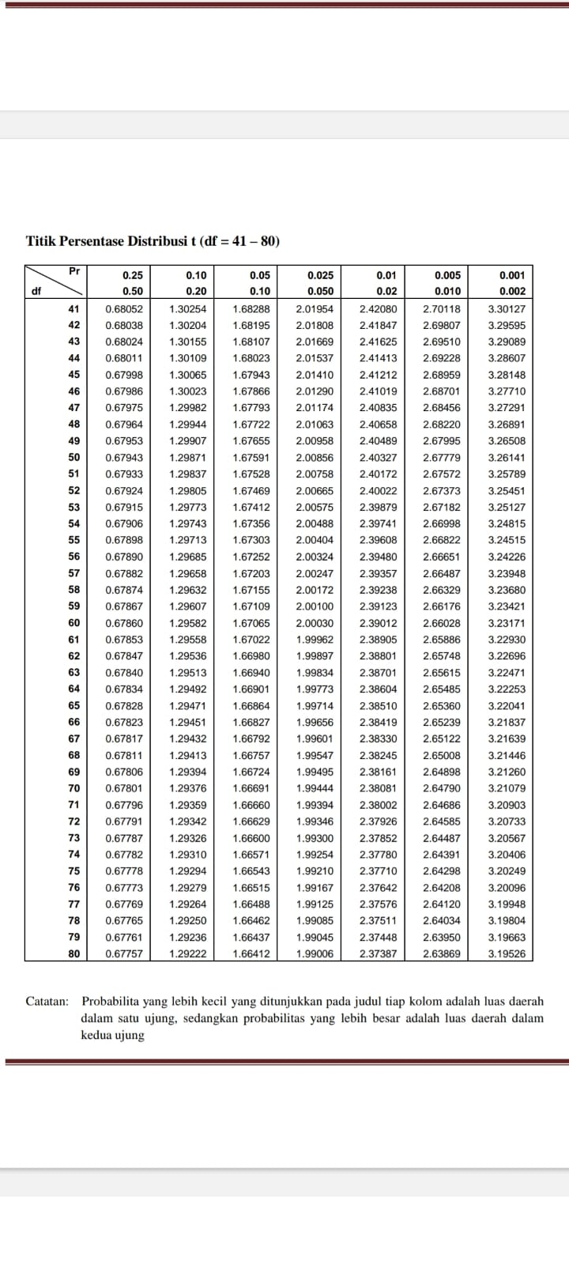

# **APPENDIX IV**

## **Letters**

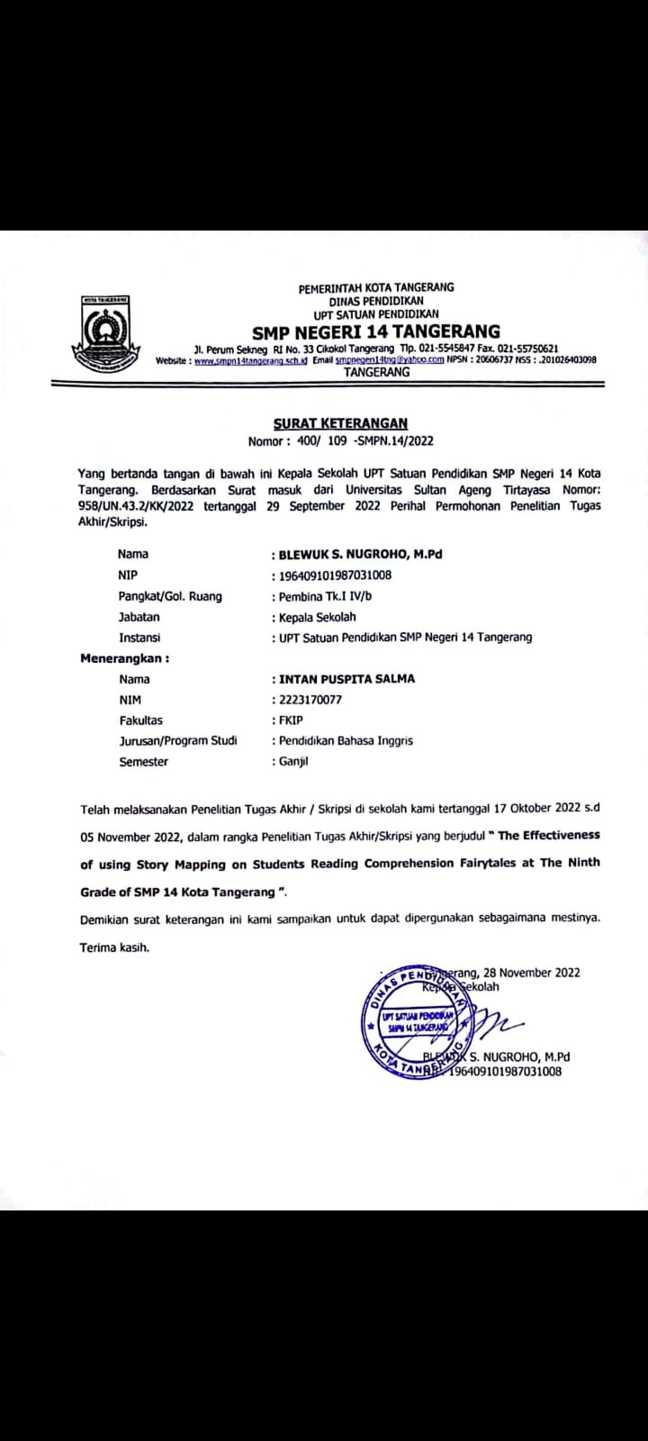

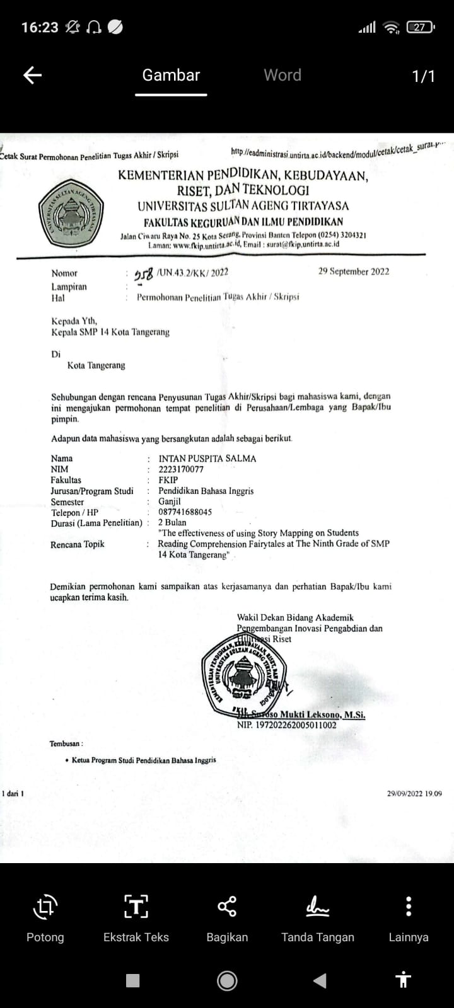

## **Documentation**

Researchers are discussing

teaching schedule in class A and B

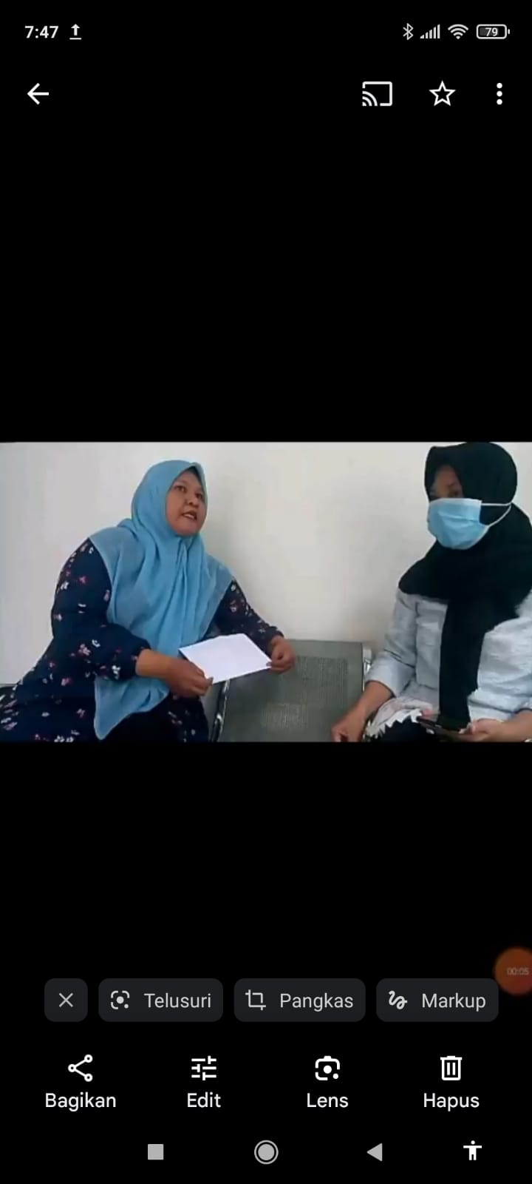

Researcher explains Narrative Text

Material in Control class using lecture strategy

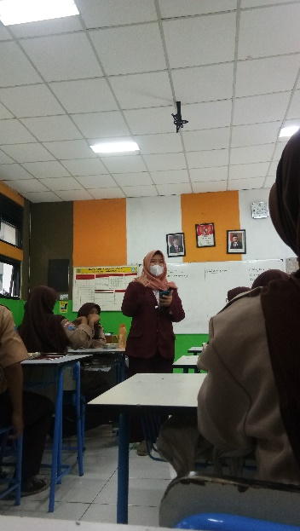

Control class students working on multiple choice test

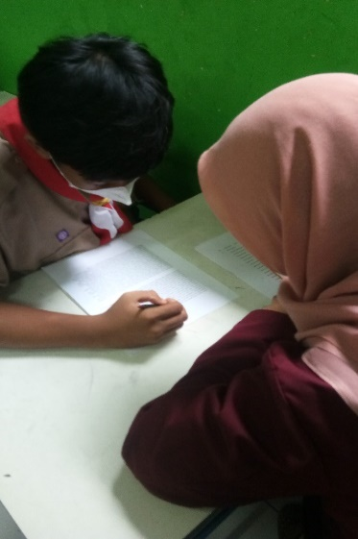

Control class students ask questions about things they don't understand

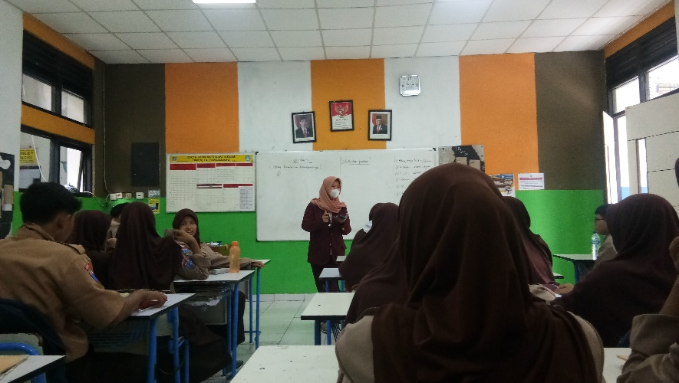

Researcher Explaining Narrative Text Structure

using Story Mapping strategy in Experiment class

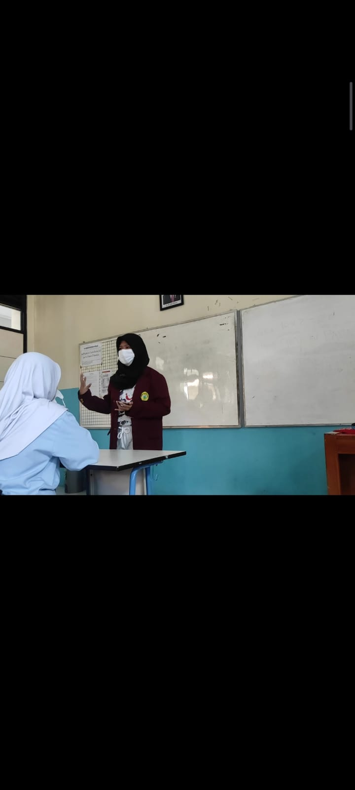

Students in the Experiment class create

Story Mapping structure

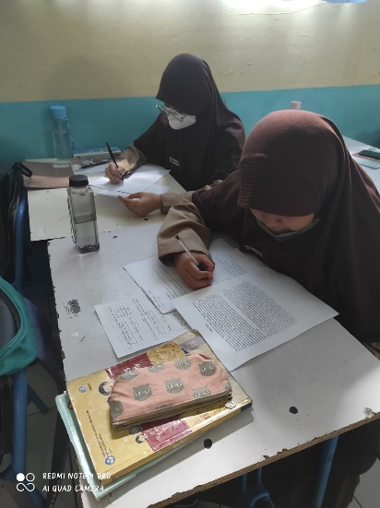Experiment class students

working on Multiple choice test

