**ANALYSIS STUDENTS’ HIGHER ORDER THINKING AND CRITICAL THINKING SKILLS ON PLANT TISSUE TOPIC IN GRADE**

**XI SCIENCE SMAN 2 KISARAN ACADEMIC**

**YEAR 2019/2020**

**Elisa Lumbantungkup, Hasruddin**

Department of Biology Education, Undergraduate Program, Universitas Negeri Medan

**Abstract :** *This research aims to know students’ higher order thinking and critical thinking skills on plant tissue topic in grade XI Science. The research was conduted in senior high school grade XI Science of SMAN 2 Kisaran, and the sample was taken by random sampling, by taking 2 science classes in grade XI. The kind of this research is descriptive quantitative. The number of each test, higher order thinking skills test is and critical thinking skills test is 15 items , so the total is 30 items. The tests was validated by experts in plant tissue topic before used as the instrument research, followed by using instrument testing validity test, reliability test, difficulty level test and discrimination power. The result of research are the students’ higher order thinking skills of plant tissue topic in grade XI Science SMAN 2 Kisaran is good categories. The achievement of Higher-order thinking skill of students grade XI in this school is in good level because the value of the higher order thinking achievement of students in class XI MIPA is about 70-79%. If the higher-order thinking achievement of the two class is averaged, a score of 75.84% is obtained. The students’ critical thinking skills of plant tissue topic in grade XI Science SMAN 2 Kisaran is still in less categories. The achievement of critical thinking skill of students grade XI in this school is in less level because the value of the higher order thinking achievement of students in class XI MIPA is about <50-69%. If the critical thinking achievement of the two class is averaged, a score of 55.86% is obtained.*

**Keyword** *: higher order thinking skills, critical thinking skills, plant tissue topic*

1. **Introduction**

Education in Indonesia has always undergone improvements which in the end produce a quality education product or result. Various efforts have been made in order to improve the quality of existing education, to be able to create a reliable future generation capable of facing various life challenges. These improvements include the improvements in the education system or things directly related to learning practices. The policy on the 2013 curriculum was designed by the Indonesian government through Ministerial Regulation No. 22 of 2016 concerning process standards, it is clear that as a curriculum improvement plan it is expected that students can develop themselves in thinking. Students are required not only have lower order thinking skills (LOTS), but also higher order thinking skills (HOTS). According to Kratwhwol and Anderson (2001), states that indicators for measuring HOTS include analyzing (C4), evaluating (C5), and creating (C6) (Nuragni, 2018).

According to Retnawati (2018), HOTS is most easily identified through Bloom's taxonomy. With revised Bloom’s taxonomy proposed by Anderson and Kratwhwol (2001), HOTS indicators can be easily formulated in learning. In the revised Bloom’s taxonomy, the cognitive process dimension is seen as a verb which serves to describe a particular process, while the knowledge dimension is seen as a noun which functions as the object of the process carried out. The existence of these two components (verb and noun).

Critical thinking is thinking that examines, connects and evaluates all aspects of a situation or problem, including its performance gathering, organizing, remembering and analyzing information (Helmawati, 2019).

According to Sani (2019), critical thinking is convergent thinking, whereas creative thinking is divergent thinking, convergent thinking is a process of processing information from various points of view to get conclusions. Whereas divergent thinking is the development of the mind from an information into various ideas or points of view. Individuals who are able to think creatively will be able to produce new concepts, ideas or products that are different from existing concepts, ideas or products. The ability to think critically and think creatively (higher order thinking skills) is needed by someone in solving a complex problem.

1. **Research Type and Design**
   1. **Research Design**

Researcher use descriptive research method which following by quantitative research approach that analyse the students’ ability in answering higher order thinking skills and critical thinking questions on plant tissue topic in grade XI science SMA Negeri 2 Kisaran academic year 2019/2020. This research is descriptive research because it is not necessary to control a treatment or is not intended to test the hypothesis.

This research is designed by giving multiple choice test to measure the students’ skills in answering the higher order thinking and critical thinking questions to all of the sample classes which consist of two classes, namely XI MIPA 1 and XI MIPA 2. Students’ answers result obtained are analysed to find out the students’ skills in answering higher order thinking and critical thinking questions.

* 1. **Data Sample**
     1. **Location**

This research was conducted in SMA Negeri 2 Kisaran at Jl. Sitarda Nusantara VIII, Kisaran Naga, Kisaran City 21224, during August – October 2019..

* + 1. **Sample**

The sample in this research is chosen by using random sampling because there were no strata of the population. Techniques of random sampling can be done because the population is homogeneous (Pohan and Syahwin, 2017). The sample is used to select two classes out of population for the research and the samples are XI MIPA 1 and XI MIPA 2.

* 1. **Instrument**

The instrument used in this research is multiple choice tests based on revised Bloom’s Taxonomy in higher order thinking and critical thinking cognitive level. For higher order thinking skills, questions given in this research consist of 15 items covering levels C4, C5 and C6 according to Bloom's taxonomy while for critical thinking skills completed by giving multiple choice questions which consist of 15 items covering levels C4 and C5 according to Bloom's taxonomy.

1. **Result and Discussion**
   1. **Result**

**3.1.1. Result of Students’ Higher Order Thinking Skills on Plant Tissue Topic**

There are four questions include to C4 cognitive dimension, six questions include to C5 cognitive dimension and six questions include to C6 cognitive dimension. The following is a table that shows the achievement of higher order thinking skills for students in grade XI science SMAN 2 Kisaran.

**Table 3.1.** Achievement of Critical Thinking Skills of students in grade XI science SMAN 2 Kisaran

|  |  |
| --- | --- |
| **Class** | **Percentage Value (PV) of Critical Thinking Skills of Students in Grade XI SMAN 2 Kisaran** |
| XI MIPA 1 | PV Average (%) 61.84 |
| XI MIPA 2 | PV Average (%) .49.62 |
| **Average of PV (%) 55.73** | |

From Table 3.1 above, it can be seen that the average percentage of students critical thinking skills at SMAN 2 Kisaran is 55.73%. The value obtained is in "less category" because the range is between >50-69%. The results of of class XI MIPA 1 gets a higher score of critical thinking skills than class XI MIPA 2. From the percent value of each class, class XI MIPA 1 obtained a critical thinking skills achievement 61.84%. Class XI MIPA 2 obtained a higher order thinking ability achievement 55.73%.

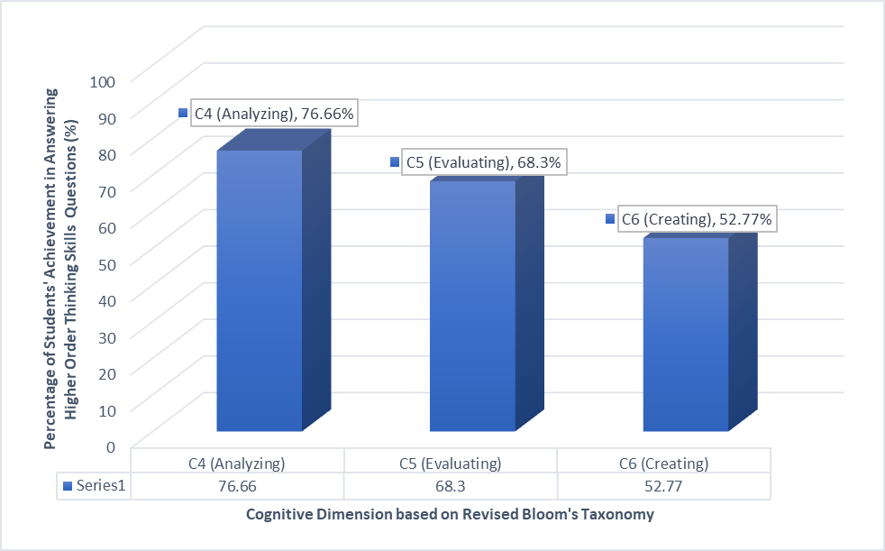

**Figure 3.1.** Students’ Higher Order Thinking Skills on Plant Tissue Topic

* + 1. **Result of Students’ Critical Thinking Skills on Plant Tissue Topic**

There are eight questions includes to C4 cognitive level and seven questions includes to C5 cognitive level. The following is a table that shows the achievement of critical thinking skills students in grade XI science SMAN 2 Kisaran.

**Table 3.2.** Achievement of Critical Thinking Skills of students in grade XI science SMAN 2 Kisaran

|  |  |
| --- | --- |
| **Class** | **Percentage Value (PV) of Critical Thinking Skills of Students in Grade XI SMAN 2 Kisaran** |
| XI MIPA 1 | PV Average (%) 61.84 |
| XI MIPA 2 | PV Average (%) .49.62 |
| **Average of PV (%) 55.73** | |

From Table 3.2 above, it can be seen that the average percentage of students critical thinking skills at SMAN 2 Kisaran is 55.73%. The value obtained is in "less category" because the range is between >50-69%. The results of of class XI MIPA 1 gets a higher score of critical thinking skills than class XI MIPA 2. From the percent value of each class, class XI MIPA 1 obtained a critical thinking skills achievement 61.84%. Class XI MIPA 2 obtained a higher order thinking ability achievement 55.73%.

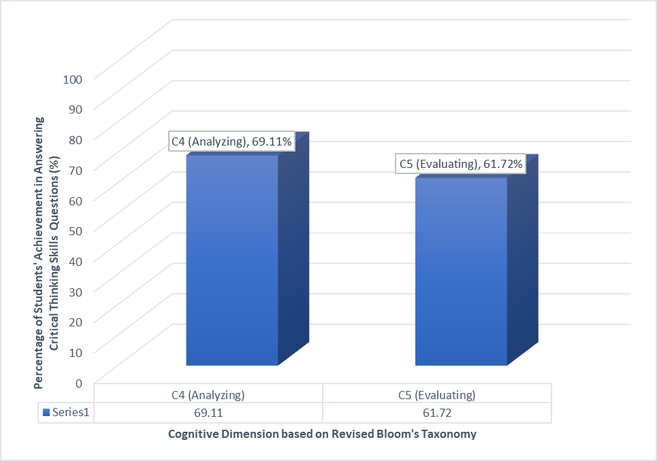

**Figure 43.2.** Students’ Higher Order Thinking Skills on Plant Tissue Topic

* 1. **Discussion**

Overall, about less than half of the higher order thinking questions were answered correctly by students in both XI MIPA 1 and XI MIPA 2. It means that the students have less category in answering higher order thinking skills questions in plant tissue topic. For XI MIPA 1 students seem have better higher order thinking skills than XI MIPA 2, it can be seen almost all of the students got more score. From the result, it can be found that there are some questions that are difficult for the students to be answered, there are 3 range of difficult questions, namely question number 8 (C5), 10 ( C6) and 14 (C6).

Overall, about less than half of the critical thinking questions were answered correctly by students in both XI MIPA 1 and XI MIPA 2. It means that the students have less critical thinking skills in plant tissue topic. For XI MIPA 1 students seem have better critical thinking skills than XI MIPA 2, it can be seen almost all of the students got more score. From the result, it can be found that there are some questions that are difficult for the students to be answered, there are 3 range of difficult questions, namely question number 1(C4), 6(C4) and 15(C4)

The Students’ Higher Order Thinking and Critical Thinking Skills Based on Cognitive Aspect of Revised Bloom’s Taxonomy

a. Analyzing Aspect (C4)

In this level, the student breaks learned information into its part to best understand that information in an attempt to identify evidence for a conclusion (Anderson and Krathwohl, 2002). From the results of the students’ answers indicate that students have ability in anwering higher order thinking and crtitical thinking skills questions are 76.66% and 69.11% averaged 72.88% of students who are able to answer the higher order thinking and critical thinking skills questions. Some of the students have difficulty analyzing characteristics (location and structure) and differentiating the functions of various tissues in plants. For example in higher order thinking question number 1 and critical thinking question number 3 which belongs to the second indicator (distinguishing the characteristics of all permanent tissue), many students have difficulty in showing the characteristics of the meristem tissue from several statements presented. The averaged score 72.88% indicates the ‘enough category’ of students’ achievement in analyzing (C4) cognitive dimension.

b. Evaluating Aspect (C5)

In this level, the student makes decisions based on in-depth reflection, criticism, and assessment. In this level, the analysis refers to an ability to breaks or rearranged the information that already got by them become clear elements. The ability included analyzing of elements (parts of information), analyzing of relation, analyzing of the organization (Anderson and Krathwohl, 2002). From the results of the students’ answers indicate that students have ability in anwering higher order thinking and crtitical thinking skills questions are 68.3% and 61.72% averaged 65.01% of students who are able to answer the higher order thinking and critical thinking skills questions. Many students experience difficulties in determining the most correct statement from several statements relating to plant tissue. For example in higher order thinking question number 8 and critical thinking question number 12 which belongs to the third indicator (comparing the cell structure of plant tissue on figure), many students have difficulty in showing the structure of plant tissue from several figures presented. The averaged score 65.01% indicates the ‘less category’ of students’ achievement in evaluating (C5) cognitive dimension.

c. Creating Aspect (C6)

The highest level of the cognitive domain is the creating level, where the student creates new ideas and information using what has been previously learned (Anderson and Krathwohl, 2002). From the results of the students’ answers indicate that students have ability in anwering higher order thinking is 52.77%. Many students experience difficulties in expressing and developing ideas, solutions and methods in the material discussed. For example in question number 10, many students have difficulty in explaining the totipotency and plant tissue culture technique. The same thing is found in question number 9, many students have difficulty in explaining the differences between meristem and permanent tissue. The students did not answer the question correctly in this cognitive aspect because they have difficulty during creating a new idea to make hypothesize and develop experimental design, but they seldom do experiment for studying this topic and of course it makes most of students failed to answer these questions. The score 52.77% indicates the ‘less category’ of students’ achievement in creating (C6) cognitive dimension.

**Conclusion**

Based on the research, it can be concluded that the value of the higher order thinking achievement of students in in grade XI Science SMAN 2 Kisaran is 70.73% in range 70-79% which indicates that the students’ critical thinking skills is in "good category". While the value of the critical thinking achievement of students in in grade XI Science SMAN 2 Kisaran is 55.73% in range <50-69% which indicates that the students critical thinking skills is in "less category".

**References**

[1] Anderson, L. W., and Krathwohl., (2001), A Taxonomy for Learning, Teaching, and Assessing: A Revision of Bloom's Taxonomy of Educational Objectives, Penerbit Longman, New York.

[2] Anni, C., (2012), Psikologi Belajar, Semarang, UPT UNNES

[3] Arends, R. I., & Kilcher, A., (2010), Teaching For Student Learning Becoming An Accomplished Teacher, New York, Routledge.

[4] Arikunto, S., (2011), Prosedur Penelitian: Suatu Pendekatan Praktik, Edisi Revisi VII, Jakarta, PT. Rineka Cipta.

[5] Bookhart, S. M., (2010), How To Assess Higher Order Thinking Skills In Your Classroom, Alexandria, VA, ASCD.

[5] Cimer, A., (2012), What Makes Biology Learning Difficult and Effective: Students’ Views, Educational Research and Review, 7 (3): 61-71.

[6] Conklin, W., (2012), Higher-Order Thinking Skills for develop 21st Century Industry, Hutington Beach, Shell Educational Publishing, Inc.

[7] Mulyasa, (2013), Pengembangan dan Implementasi Kurikulum 2013, Bandung, Remaja Rosdakarya.

[8] Erfan, M., and Ratu, T., (2018), Pencapaian Hots (Higher Order Thinking Skills) Mahasiswa Program Studi Pendidikan Fisika Fkip Universitas Samawa, Jurnal Pendidikan Fisika dan Teknologi, 4(2): 208-212.

[9] Ekawati, Y. N., (2016),The Implementation of Curriculum 2013: A Case Study of English Teachers’ Experience at Sma Lab School in Indonesia, English Language Learning Journal, 7(1): 84-90.

[10] Enggen, P., & Kauchak, D., (2012), Strategi dan model pembelajaran: mengajarkan konten dan keterampilan berpikir, (Terjemahan Satrio Wahono), Boston, MA, Pearson Education.

[11] Gais, Z., and Afriansyah, E. A., (2017), Analisis Kemampuan Siswa dalam Menyelesaikan Soal High Order Thinking Ditinjau dari Kemampuan Awal Matematis Siswa, Jurnal Mosharafa, 6(2): 255-266.

[12] Halpern, D.F., (2014), Thought and Knowledge: An Introduction to Critical Thinking, New York, Taylor and Francis.

[13] Helnawati, (2019), Pembelajaran dan Penilaian Berbasis HOTS (Higher Order thinking Skills), Bandung, Remaja Rosdakarya.

[14] Hermino, A., (2016), Asean Economic Community in The Perspective of Transformational Leadership in School, International Journal of Education and Research, 4(6): 401-415.

[15] Irnanigtyas, (2013), Biologi untuk SMA/ MA Kelas XI, Penerbit Erlangga, Jakarta.

[16] Kemendikbud, (2014), Concept and Implementation of Curriculum 2013. Kementrian Pendidikan dan Kebudayaan, Jakarta, Indonesia.

[17] King, F. J., Goodson, L., & Rohani, F., (2010), Higher Order Thinking Skills: Definition, Teaching Strartegis, Assesments, http://goo.gl/su233T.

[18] Krulik, S., & Rudnick, J. A., (1999), Innovate Ttask To Improve Critical And Creative Thinking Skill, Developing Mathematical Reasoning in Grades K-12 (pp.138), Reston, VA, NCTM.

[19] Kusnawa, W. S., (2013), Taksonomi Berpikir, Bandung, Remaja Rosdakarya.

[20] Nuragni, W. T., (2018), Analisis Kemampuan Siswa dalam Menyelesaikan Soal Tipe Higher Order Thinking pada Pokok Bahasan Pola Bilangan di Kalangan Siswa Kelas VIII E SMP N 5 Yogyakarta Tahun Ajaran 2018/2019, Yogyakarta, Jurusan Matematika, Universitas Sanata Dharma.

[21] Nugroho, R. A., (2018), HOTS: Higher Order Thinking Skills, Jakarta, PT. Gramedia Widiasarana Indonesia.

[22] Pohan, L. A., and Syahwin, (2017), Identification of Acid-Based Concept Understanding Using the Assessment of A Two Tier Multiple Choice Diagnostic Instrument, Multidisciplinary Research (ICMR), jurnal.unsiyah.ac.id.AICS-Social/article/download.

[23] Pressesen, B.Z., (1985), Thinking skill; meanings and models, Developing minds; A resource book for teaching thinking (pp.43-48), Alexandria, VA, ASCD.

[24] Retnawati, H., Djidu, H., Kartianom., Apino, E., Anazifa, R. D., (2018), Teachers’ Knowledge About Higher-Order Thinking Skills And Its Learning Strategy, Educational Journal, 76(2): 2015-230.

[25] Ruggiero, V. R.,(2003), Beyond Feelings: A Guide To Critical Thinking, United States, Mc.Graw-Hill.

[26] Rifai, A and Anni, C. T., (2009), Psikologi Pendidikan, Semarang, UNNES PRESS

[27] Sani, (2019), Pembelajaran Berbasis HOTS (Higher Order Thinking Skills), Tangerang, Tira Smart.

[28] Setiawati, S., (2019), Analisis Higher Order Thinking Skills (Hots) Siswa Sekolah Dasar Dalam Menyelesaikan Soal Bahasa Indonesi, Prosiding Seminar Nasional Pendidikan KALUNI, 1(2): 552-557.

[29] Slamento., (2010), Belajar dan Faktor-Faktor yang Mempengaruhinya, Jakarta, Rineka Cipta.

[30] Soyamukti, N., (2013), Teori-teori Pendidikan Tradisional, (Neo) Liberal, Marxis-Sosislis, Postmodern, Jogjakarta, Ar-Ruzz Media.

[31] Tekkaya, C. O., (2001), Biology Concept Perceived as Difficult by Turkish High School Students, Hacettepe Universitesi Egitim Fakultesi Dergisi, 21: 145-150.

[32] Utami, M., (2016), Identifikasi Kesulitan Belajar Materi Struktur-Fungsi Jaringan Tumbuhan pada Siswa SMA Negeri 3 Klaten Kelas Xi Tahun Ajaran 2015/2016, Jurnal Pendidikan Biologi, 5 (7): 19-26.

[33] Zuhri, M., (2018), Buku Pegangan Pembelajaran Berorientasi pada Keterampilan Berpikir Tingkat Tinggi: Program Peningkatan Kompetensi Pembelajaran Berbasis Zonasi, Jakarta, Dirjen Guru dan Tenaga Kependidikan Kemendikbud.