Improving Community Skills in Making Processed Fish Products in Paluh Kurau Village, Deli Serdang, North Sumatra

Muhammad Ridha Syafii Damanik^{1*}, OK Sofyan Hidayat² , Meilinda Suriani Harefa³, Darwin Parlaungan Lubis⁴
^{1,3,4}Jurusan Pendidikan Geografi, Fakultas Ilmu Sosial, Universitas Negeri Medan
²Jurusan Akuntansi, Fakultas Ekonomi, Universitas Negeri Medan
Jl. Willem Iskandar Pasar V – Kotak Pos No. 1589 – Medan 20221

Email Corresponding: mridhadamanik@unimed.ac.id

Submitted:  25-11-2021 | Accepted:  28-12-2021 | Published:  19-04-2022

Abstract
The purpose of this community service is to find and increase the income generated by Medan State University which has been designated as a Public Service Agency in 2018. When a government institution turns into a Public Service Agency, it will be required to be independent in financial management including in terms of income management. This community service activity is a continuation of the previous year, where the Department of Geography Education, has pioneered the sale of online fresh fish which is a source of income generation. In 2021, the business unit will develop its products not only in fresh fish products but also in processed fish products with high economic value. In addition, this activity aims to help partner community groups to produce processed fish products to be marketed in the Medan State University Business Unit.
The stages carried out in this activity are to collaborate with partners. Furthermore, conducting a series of training and mentoring for partner groups so that they can produce processed fish products that are in accordance with standards so that they are worthy of being marketed. This training and mentoring process was carried out in Paluh Kurau Village, District of Perak, Deli Serdang Regency.
The output of this activity is the availability of processed fish products which can increase the income of partner groups and become an income generator for Medan State University.
Keywords: Business Unit, Processed Fishery, Income Generating

INTRODUCTION

The Malacca Strait has been known as a waters with a very high fishery potential. It is included as one of the Fisheries Management Areas (WPP) in Indonesia, specifically in WPP 571 (Damanik et al., 2016). Fishery potential in WPP 571 is estimated to be 425,444 tons, with the potential to be caught at 340,355 tons (darilaut.id, 2019). WPP 571 includes waters in Paluh Kurau Village, Hamparan Perak Sub-district, Deli Serdang Regency, North Sumatra Province.
The potential of fish in Paluh Kurau Village, Hamparan Perak Sub-district, Deli Serdang Regency is relatively large. This is associated with Paluh Kurau Village, which is directly adjacent to the Malacca Strait. This village is located + 1 meter above sea level, and has a distance of 35 kilometers from the sub-district capital, but 20 kilometers to the regency capital. This village, like other coastal villages, has limited infrastructure, including roads and transportation, as well as clean water, electricity and communications. Roads and transportation within the village and outside the village are still inadequate. Thus, village products and population mobility are more likely to be marketed using sea transportation. This state of infrastructure also limits the progress and socio-economic growth of the coastal area. Referring to data generated by BPS In 2020, the population of Paluh Kurau Village was amounted to 6,525 people (1,676 families) (BPS Kabupaten Deli Serdang, 2020). People in Paluh Kurau village generally have a livelihood depending on the utilization of coastal and marine resources, specifically in the fisheries sector (Suharyanto et al., 2017). The low income of the community is considered as a general problem, which is associated with several factors, including the low level of community knowledge in processing fishery products, resulting in higher economic value (Tampubolon, 2011). The community is still dependent on the sale of fresh fish, which is relatively cheap and does not provide high economic value. Therefore, group partners are highly required to innovate processed fish in order to have an economic value as an effort to increase the economy level (Tampubolon, 2011).

METHODS
This research was classified as an action research. Action research is perceived as a research method that is able to provide solutions to social problems (Suroto et al., 2017). This research was carried out in Paluh Kurau Village, Hamparan Perak Sub-District, North Sumatra Regency, North Sumatra Province, from July to November 2021 by involving partners, specifically the Melati Group II in Paluh Kurau Village. The stages of research implementation are described as follows:

- Preparation Stage
This preparatory stage was initially carried out through coordination with the Business Management Agency (BPU) of Unimed and continued with observing the location of community service activities for the two target partners, specifically the Semangat Karya and Marine Fishermen groups in Paluh Kurau Village, Hamparan Perak Sub-district, Deli Serdang Regency to discuss the strategy for implementing community service in the region. Furthermore, the researchers coordinated with LPPM UNIMED and agencies, regarding coordination and permits for the implementation of activities and agreed on the implementation date.
At this preparatory stage, the research team prepared infrastructure facilities for the implementation of activities such as minimum standard equipments owned by target partners in business development. These equipments were planned to be used during the implementation of research activities.

- Implementation Stage
a. Business Strategy Preparation
At this stage the team would coordinate with the BPU of Unimed to determine the business strategy carried out, including the sales system, profit sharing, marketing mechanism, product standards, and packaging standards. This stage should be carried out to ensure the conformity of the entire set of business units with the applicable rules at Unimed.
b. Production Training
The processed products chosen to be trained at this stage were the productions of nuggets, tempura, and dimsum made from fish. The selection of this type of preparation was based on its high nutritional content (Kresnasari et al., 2019). This production training was carried out by partner groups, starting from the selection of processed raw materials to training on processing methods. This activity involved the role of partners in the production processing process.
The training materials were provided to each training participant to facilitate them to repeat the production process independently, according to the material guide provided. Therefore, the readiness of partner groups to become nugget, tempura, and dimsum entrepreneurs can develop effectively in order to improve their family's economy.
Packaging Design and Marketing Training
In this training, partner groups were provided with training on designing value-added processed product packaging. This training aims to create attractiveness in the packaging for sale besides being able to function for food protection. Furthermore, from the packaging training, partner groups were trained in the skills of marketing processed products to consumers, leading to the sustainability of the business being developed.

- Mentorship
After training, partner groups would be guided to a skilled level. The mentorship targets for this partner group are as follows:
- Partners have skillfully processed nuggets, tempura, and dimsum products and innovated with processed products, thereby being able to modify the preparations with a distinctive taste.
- Partners already have a distinctive packaging design that characterizes the partner's processed production.
- Partners already have a market that accommodates partners' processed products.
- Partners have been able to arrange administration and bookkeeping to manage their nugget, tempura, and dimsum businesses

Table 1 Activity Plan
No | Activity Plan | Approach Method | Goals/Output | Partner Participation
1 | Observation Activities | Identify the needs of partner groups in business development | Partner business development potential data | Active in the delivery of data on the existence and potential of partners
2 | Supply and use of nugget, tempura, and dimsum processed equipment | Preparing business implementation equipment in accordance with minimum standards of business development and trials of the use of tools by  Friend | Minimum standard processing tools owned by partners and trained partners use them | Partners actively practice using equipment for processing nuggets, tempura, and dimsum as the partner's superior product
3 | Nugget, tempura, and dimsum production training | Practice and simulation | Proficient in processing nuggets, tempura, and dimsum that have the characteristics of partner's superior products | Actively participate in product processing training
4 | Packaging and marketing training | Packaging design practices | Packaging design | Actively select packaging designs and find markets for containerized nugget, tempura, and dimsum processed products produced by partners

RESULTS AND DISCUSSION
In this research activity, the partner groups were able to obtain business assets in the form of processing equipment consisting of cooking utensils, spice grinders, and packaging equipment. This achievement indicated that the business equipment capital problem could be addressed by the partner groups. All of these equipment had been used by partners to develop the business of making fish nuggets, tempura, and dimsum.

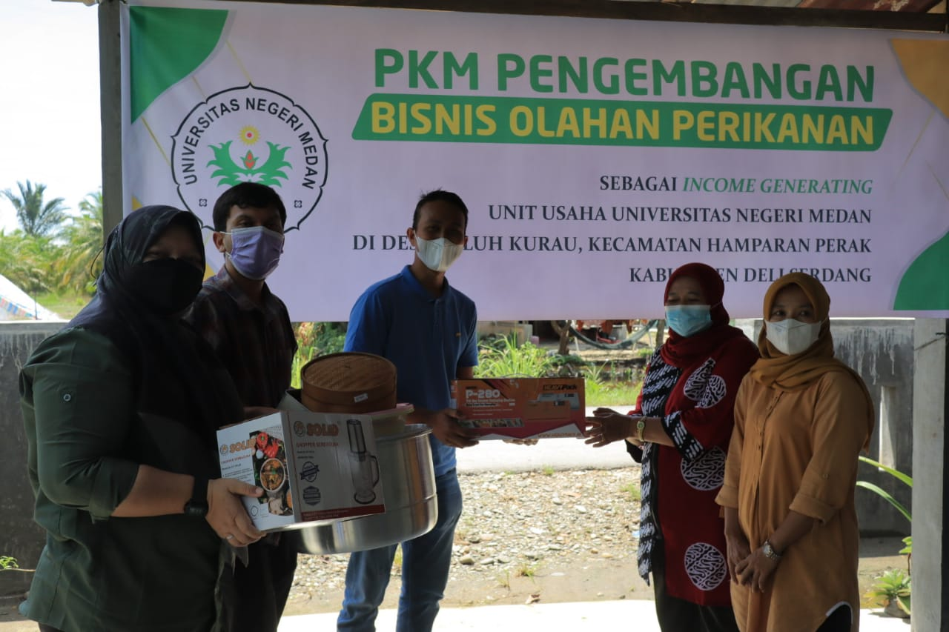
Figure 2. Handing the fish processing equipment as an asset for the partner group.

The implementation of training on the production of processed fish products in Paluh Kurau Village had been successfully carried out in accordance with the activity plan. Partner community groups were enthusiastic in participating and receiving assistance from the community service team. Partners had also been able to process milkfish and tilapia into nugget, tempura, and dimsum. In this activity, 10 fisherwomen had succeeded in being skilled in making processed fish-based products.

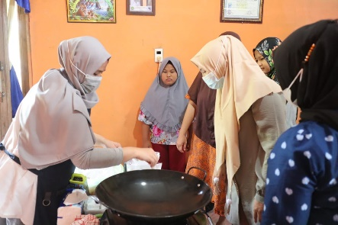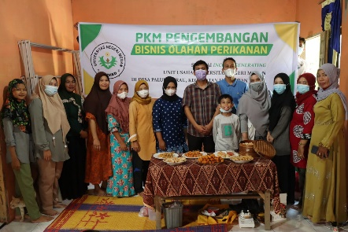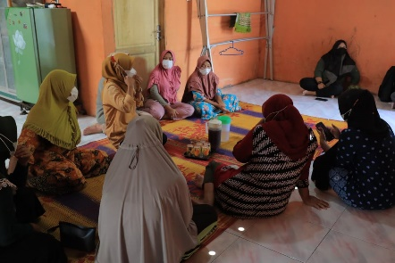
Figure 3. Implementation of Fish Processed Manufacturing Training (Source: Implementation Activities, 2021).

At the implementation stage of the training on making fish-based nuggets, tempura, and dimsum, community groups had been able to produce 1 kg of each nugget, tempura, and dimsum. Nuggets, tempura, and dimsum were made from snapper. This type of fish does have a high capital price. However, as an early stage of production, it was necessary to use basic ingredients with high quality to produce a better taste. In the assessment of product results, the taste of the nuggets, tempura, and dimsum produced was considered very satisfying.
Partner groups had been considered capable of processing nuggets, tempura, and dimsum. The ability of the partner groups to follow and carry out every step and stage of work was in accordance with the established procedures. Hygienic aspects and work order of partner groups were also considered good.

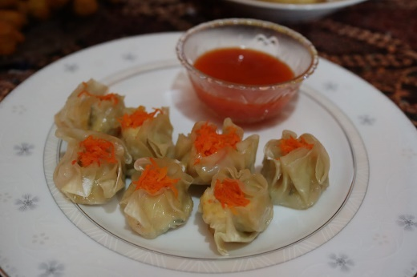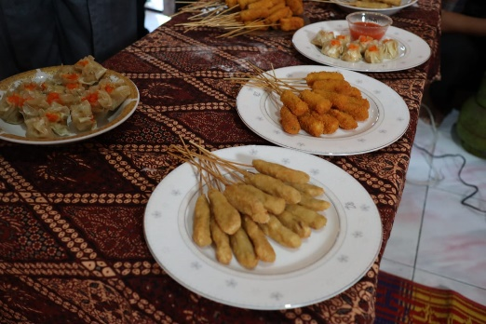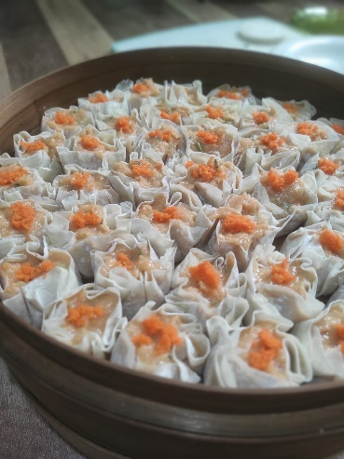
Figure 4. Partner group work process in processing nuggets, tempura, and dimsum (Source: Implementation Activities, 2021).

To increase the value of the product, nuggets, tempura, and dimsum were packaged in more hygienic and attractive packaging. Partner groups were also assisted to package products. Practically, processed nuggets, tempura, and dimsum products were packaged by utilizing styrofoam and plastic wrapping to maintain product durability and hygiene. As a result, partner groups were capable of being involved in packaging training properly and were able to pack products very neatly (Figure 5). The resulting packaging was considered to be very great and in accordance with appropriate standards for the modern market.

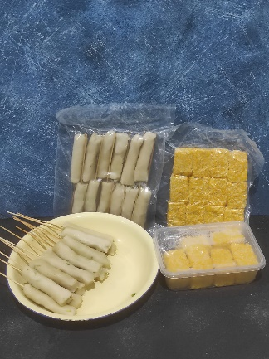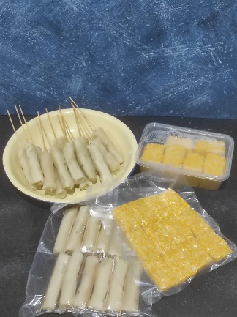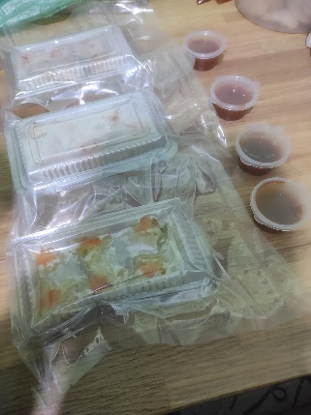
Figure 5. Processed products of nuggets, tempura, and dimsum that have been packaged (Source: Implementation Activities, 2021).

The implementation of this research activity also emphasized the aspects of innovation and sustainability. In terms of the innovation aspect, partner groups were also likely to develop processing on other types of fish, which have relatively cheaper prices. Consequently, the partner groups were succeeded in processing nuggets, tempura, and dimsum from Batoids and Toli Shad. These types of fish were chosen, because people were less likely to consume the fish and the raw selling price was also relatively cheap. Therefore, this type of fish could be more economically valuable if it is processed into nuggets, tempura, and dimsum. Partner groups had also tried to market these products even at the local market level. As a result, the community could sell products at IDR 10,000 per package. By this price, partner groups could generate profits of 80-120% from the raw material capital. However, the products sold had not been standardized by BPOM, leading to low public confidence in generated products. In addition to innovation in fish species, the partner groups also carried out other innovations by processing the resulting products into ready-to-eat ingredients in the form of processed nuggets, tempura, and dimsum. This processed product was also considered quite effective in increasing the value of the product, which can definitely continue to be developed.
In terms of sustainability, partner groups also continued to produce nuggets, tempura, and dimsum. Groups were also committed to jointly developing this business into one of the village's superior products that can be utilized to improve the welfare of the village community.

CONCLUSION
Referring to the results obtained, it may be concluded that fish processing diversification is considered as one of the most effective ways to increase people's income in coastal areas, because fishermen's catches are very susceptible to damage. With this diversification, the problem of fish damage can be avoided and the selling value of the results can be increased. The most effective target community groups for developing fish-processed diversification businesses were fisherwomen, because they were considered to have more free time. The profit that could be obtained from processed fish in the categories of nugget, tempura, and dimsum was estimated to be 80-120% of the basic capital.
The follow-up plan of this activity is to test the nutritional content of the generated products and obtain a permit from BPOM and expand its marketing area.

ACKNOWLEDGMENT
We would like to express our deepest gratitude to Medan State University, specifically the Institute for Research and Community Service of Medan State University, for funding the implementation of this research. Moreover, we would like to appreciate the partner groups of fisherwomen and the ranks of the Paluh Kurau Village apparatus, who have assisted in carrying out this research activity. We also acknowledge the support received from the entire community service team who have contributed their thoughts and time to the success of this research.

REFERENCES
BPS Kabupaten Deli Serdang. (2020). Kecamatan Hamparan Perak Dalam Angka 2020. https://deliserdangkab.bps.go.id/publication/2017/09/25/1cbca604832c6fe0a1b23325/kecamatan-hamparan-perak-dalam-angka-2017.html
Damanik, M. R. S., Lubis, M. R. K., & Astuti, A. J. D. (2016). Kajian pendekatan ekosistem dalam pengelolaan perikanan di wilayah pengelolaan perikanan (WPP) 571 Selat Malaka Provinsi Sumatera Utara. Jurnal Geografi, 8(2), 165–176.
darilaut.id. (2019, May 13). Ini Potensi di 11 Wilayah Pengelolaan Perikanan - Dari Laut. Darilaut.Id. https://darilaut.id/berita/ini-potensi-di-11-wilayah-pengelolaan-perikanan
Kresnasari, D., Mustikasari, D., & Kurniawati, A. (2019). Pembuatan Nugget Ikan (Fish Nugget) Sebagai Salah Satu Usaha Deferensiasi Pengolahan Ikan Di Sekolah Alam Banyu Belik. Cendekia: Jurnal Pengabdian Masyarakat, 1(2), 42–50.
Suharyanto, A., Siagian, D. A., Juanda, J., Panjaitan, S. P., Tanjung, S., & Situmorang, T. C. M. (2017). Persepsi Masyarakat Nelayan mengenai Pendidikan di Desa Paluh Kurau, Hamparan Perak, Deli serdang. Anthropos: Jurnal Antropologi Sosial Dan Budaya (Journal of Social and Cultural Anthropology), 3(1), 11–18.
Suroto, B., Novita, N., Pailis, E. A., Waldelmi, I., Fatkhurahman, F., & others. (2017). Metode Penelitian Tindakan Solusi Bagi Masalah Sosial. Diklat Review: Jurnal Manajemen Pendidikan Dan Pelatihan, 1(1), 25–28.
Tampubolon, D. M. (2011). Analisis Finansial Usaha Perikanan yang Berbeda Pemasaran Ikannya. Jurnal Perikanan Dan Kelautan, 16(1), 79–89.

